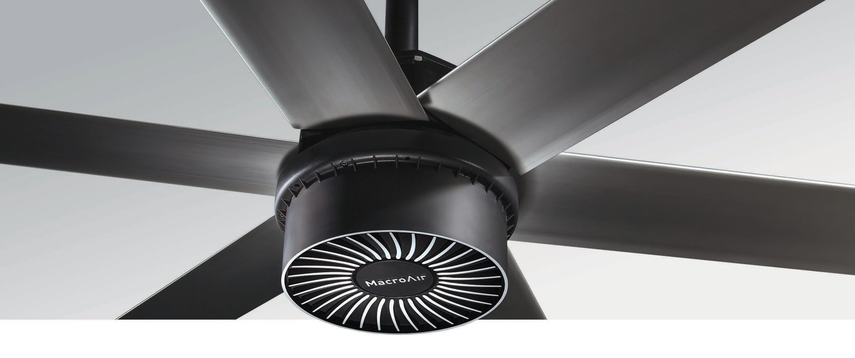
Extra-Large Spaces
Designed for heavy-duty applications, a breakthrough in motor design allows the powerful AirVolution-D 780 fan to generate 75% more wind power. This makes it perfect for extra-large spaces like warehouses, airplane hangars, airports, and stadiums. The fan’s durable design also eliminates the gearbox for easy installation, zero maintenance, and operation that’s practically inaudible. To ensure safe and reliable performance, the full line is Wash Down rated for indoor or outdoor use.

Key Specs
- Airfoil sizes 20 to 24 ft. integrate into any extra-large space.
- Airfoils also available in black and other customizable colors.
- Lighter for easy installation, less wear and tear.
- On-board AirBrain adapts to input voltages, optimizes motor control.

- No gearbox means quiet operation and no maintenance.
- Integrates into HVAC & other automated building systems via gateway.
- Wash Down Duty rated for indoor/outdoor use.
- Backed by a 50,000-hour-warranty.

Touchscreen Remote
AirVolution-D 780
HVLS Fans by
TM
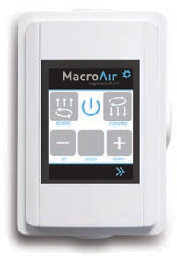
  - 20 speed settings
  - Forward and reverse
  - Integrated warranty hour counter

Warranty
Standard 50,000-hour non- prorated warranty on parts and components. Plus a
1-year warranty on labor.

Mounting Dimensions
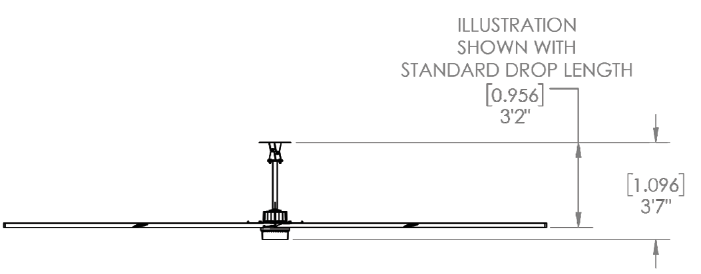Illustration shown with standard extension
extension:

AirVolution-D 780
Basic Specifications

HVLS Fans by

TM

Airfoil (Blade) Diameter | 20 ft. | 24 ft.
Airfoil Style | 7.375 inch Extruded Anodized Aluminum Airfoils
Number of Airfoils | 6
Performance
Max Speed | 75 RPM | 64 RPM
Recommended Spacing * | 105 ft. | 115 ft.
Sound Level dBA at Max Speed * * | 57 | 56
Hanging Requirements
Hanging Weight | 214 lbs | 239 lbs
Max Torque | 88 lbf/ft | 121 lbf/ft
Max Thrust in Reverse | 32 lbs | 40 lbs
Motor and Drive Train
Motor Type | Gearless Direct Drive
Equivalent Horsepower Rating | 2.1 HP
Operating Temp Range | 16ºF (-10ºC) – 140ºF (40ºC)
Max Amp Draw / Recommended Fuse
208-240 VAC Single Phase | 12.5A / 5 | 15.1A / 10
208-240 VAC Three Phase | 6.8A / 5 | 8.2A / 10
380 VAC Three Phase | 3.7A / 5 | 4.5A / 5
480 VAC Three Phase | 2.9A / 5 | 3.5A / 5
600 VAC Three Phase | 2.3A / 5 | 2.8A / 5
Power & Controls
Power Source High | Three Phase (380-600) VAC +/-5%, 50/60 Hz
Power Source Low | Single Phase or Three Phase (208-240) VAC +/-5%, 50/60 Hz
Control Options | Digital Touchpad Standard, MacroAir Controller 4, 10, 20, 30, AirLynk – BacNet/LonWorks
Installation
Mounting Hardware | Universal Mount
Drop Length | In addition to the standard drop length supplied, optional drop lengths are available in 1 inch increments.  Guy wires required with Universal Mount; with Rapid Mount guy wires are optional.
Ratings & Compliance
Fire and Sprinkler | NFPA Compliant
Outdoor Rating * * * | Rated for outdoor use.
Certifications | UL 507, CE

