AirVolution
HVLS Fans by
TM

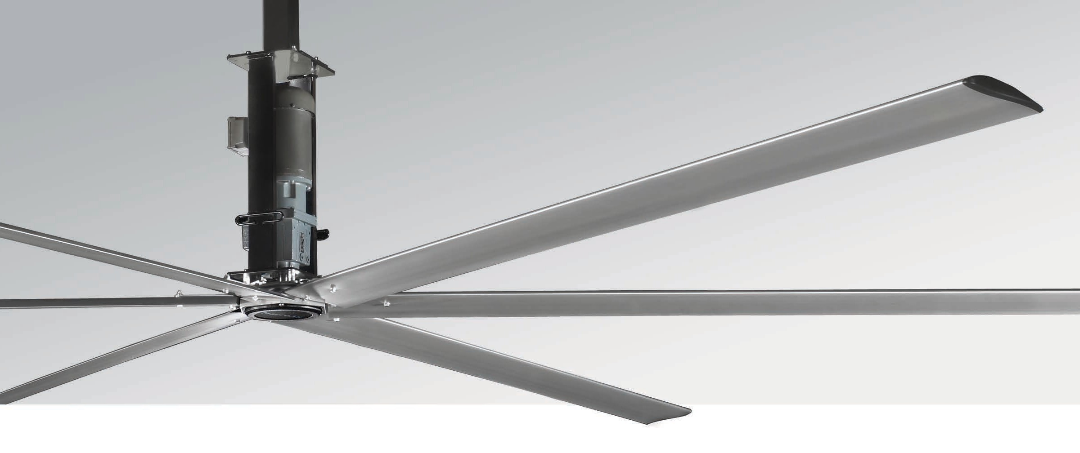
Medium to Large Spaces
The AirVolution, “Workhorse”, is ideally suited for medium to large spaces such as car dealerships, manufacturing facilities, and distribution warehouses. Moving more air than any geared motor fans in its price range. The MacroAir Legacy Series delivers the quality and eﬃciency you’ve come to expect from the company that pioneered HVLS fans.

Key Specs
- Sizes 8 – 24ft.
- Cool summers and warm winters for less than $1 per day.
- Reduce energy expenses up to 25%.
- Budget conscious solution for all environment types.
- Clearcoat anodized patented Airfoil blades.

- Forward, reverse, variable speed.
- Variable Frequency Drive – capable of ﬁre alarm and automated building systems integration.
- Digital wall controller with fault code access.
- Safety Components: Safety Cable, Universal Mount with Guy Wires, Blade Retainer Links

Touchscreen Remote
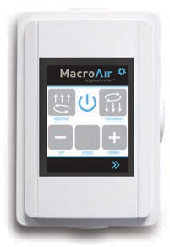
  - 20 speed settings
  - Forward & reverse

Warranty
12-year Service Life Prorated Limited Warranty

Mounting Dimensions
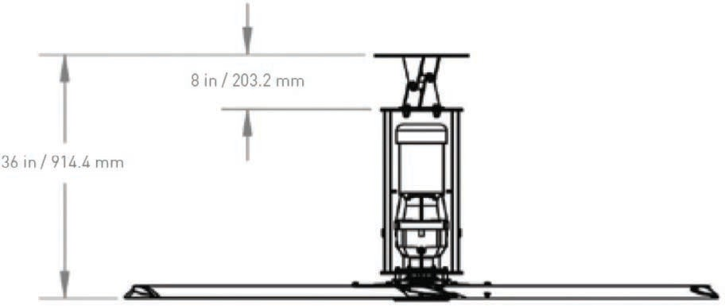
Illustration shown with standard extension:

AirVolution
Basic Specifications

HVLS Fans by

TM

Airfoil (Blade) Diameter | 8 ft. | 10 ft. | 12 ft. | 14 ft. | 16 ft. | 18 ft. | 20 ft. | 24 ft.
Airfoil Type | Extruded Anodized Aluminum Airfoils
Airfoil Width | 7.375”
Number of Airfoils | 6
Performance
Variable Speed | 0 - 209 RPM  50 ft.  58 | 0 - 162 RPM | 0 - 120 RPM  65 ft.  58 | 1 - 105 RPM | 0 - 88 RPM  85 ft.  58 | 0 - 72 RPM | 0 - 73 RPM  100 ft.  61 | 0 - 62 RPM
Recommended Industry Spacing * |  | 60 ft. |  | 70 ft. |  | 90 ft. |  | 110 ft.
Sound Level dBA at 100% Speed * * |  | 58 |  | 58 |  | 58 |  | 61
Weights
Hanging Weight | 193 lbs | 200 lbs | 211 lbs | 217 lbs | 224 lbs | 230 lbs | 239 lbs | 270 lbs
Motor and Drive Train
Motor Type | AC Induction Motor With A Sealed 2 – Staged Helical Gear Box
Equivalent Horsepower Rating | 1.0 HP (8 – 18 ft.) | 1.5 HP (20 ft.) | 2.0 HP (24 ft.)
Max Operating Temperature | 104°F [40*C]
Max Amp Draw / Recommended Fuse
100-120 VAC 1-Phase | 11.6 A / 15
208-240 VAC 1-Phase | 11.6 A / 15
208-240 VAC 3-Phase | 6.7 A / 10
480 VAC 3-Phase | 3.5 A / 5
600 VAC 3-Phase | 1.6 A / 5
Power & Controls
Power Source High | 1-Phase 100-120 VAC / 1-Phase 208-240 VAC / 3-Phase 208-240 VAC / 3-Phase 480 VAC / 600 VAC 50/60 Hz
Control Options | Digital Touchpad, MacroAir Controller 6 and 30, AirLynk – BacNet/LonWorks
Installation
Mounting Hardware | AirVolution Universal Mount
Drop Length | Optional extensions are available in 1 inch increments; all drop lengths require guy wires.
Ratings & Compliance
Fire and Sprinkler | NFPA Compliant
Certifications | UL 507 , CE

