CUDA KÄRCHER GROUP | TOP-LOAD AUTOMATIC AQUEOUS PARTS WASHERS

RUGGEDNESS
- AUTOMATION THROUGHOUT.

Top-load parts washers are the clear choice for your cleaning jobs. Pressurized hot water and specialized industrial detergents with rust inhibitors are harnessed to safely blast away dirt, grease and grime while you’re doing more productive work. Top-load parts washers clean parts automatically, increasing productivity and saving money while protecting your workers from nasty solvents and manual scrubbing. With capacities ranging from 250 to 500 lbs. and a space saving footprint, our top-load parts washers are the simple solution for your parts cleaning applications.

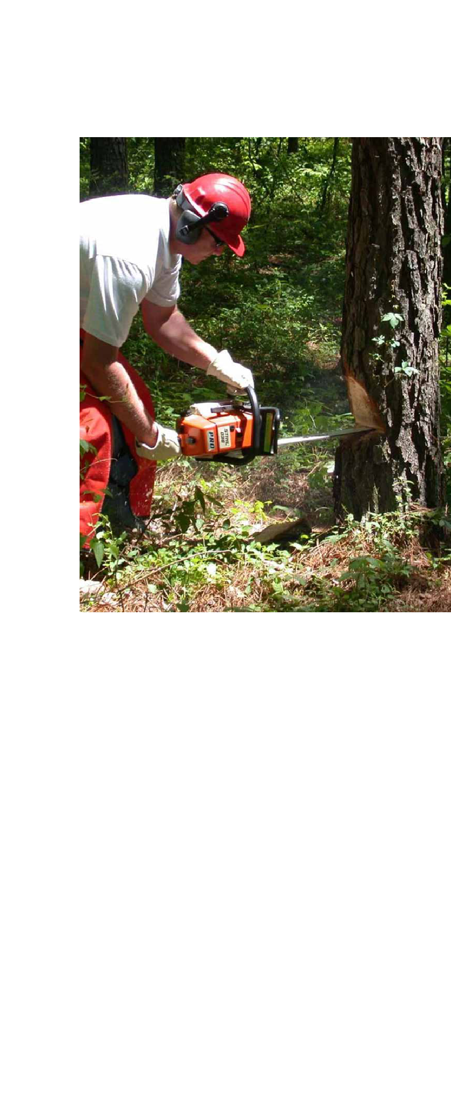

Simple Performance

Our company specializes exclusively in parts washers and accessories. Our parts washers effectively clean a variety of parts made of metal, plastic and even rubber. These systems are capable of cleaning small parts to large assemblies, limited only by the size of the cabinet itself and are especially effective in removing petroleum products, dirt carbon, and metal shavings. You can count on us to be the innovators in parts washers. The bottom line is you not only get top performance, you get more standard features and options than with any other brand.

Simply Automatic

Why waste time cleaning parts manually? You simply load the parts, close the lid and push start. A single one of our parts washers can typically support three to four technicians or mechanics who would otherwise spend hours washing parts by hand exposed to harmful solvents. Our parts washers allow them to concentrate on jobs that produce income, which means your parts washer could pay for itself in a year or less.

Environmentally Friendly, Safe To Use
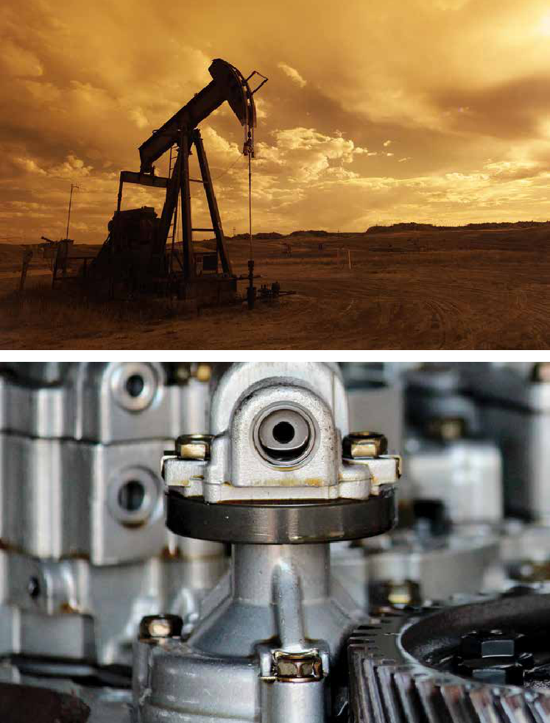

Solvents are a thing of the past. Parts washers are based on safe aqueous cleaning, so you eliminate the potential health hazards and disposal problems related to solvent use.

Nationwide Support

When you buy a parts washer from us, you’re assured of timely, professional service and support through our national network of distributors. They can provide you expert advice and support because they specialize exclusively in parts-washing equipment and supplies.

Specialized Detergents

Our detergents are designed specifically for use in our parts washers. We carefully design, blend and manufacture our own detergents to ensure they outperform all other parts cleaning detergents in the industry.

Global Cleaning Leader

Kärcher is recognized globally as a leader in cleaning solutions. In North America, Cuda Kärcher Group automatic parts washers deliver effective, time-saving solutions for professionals.

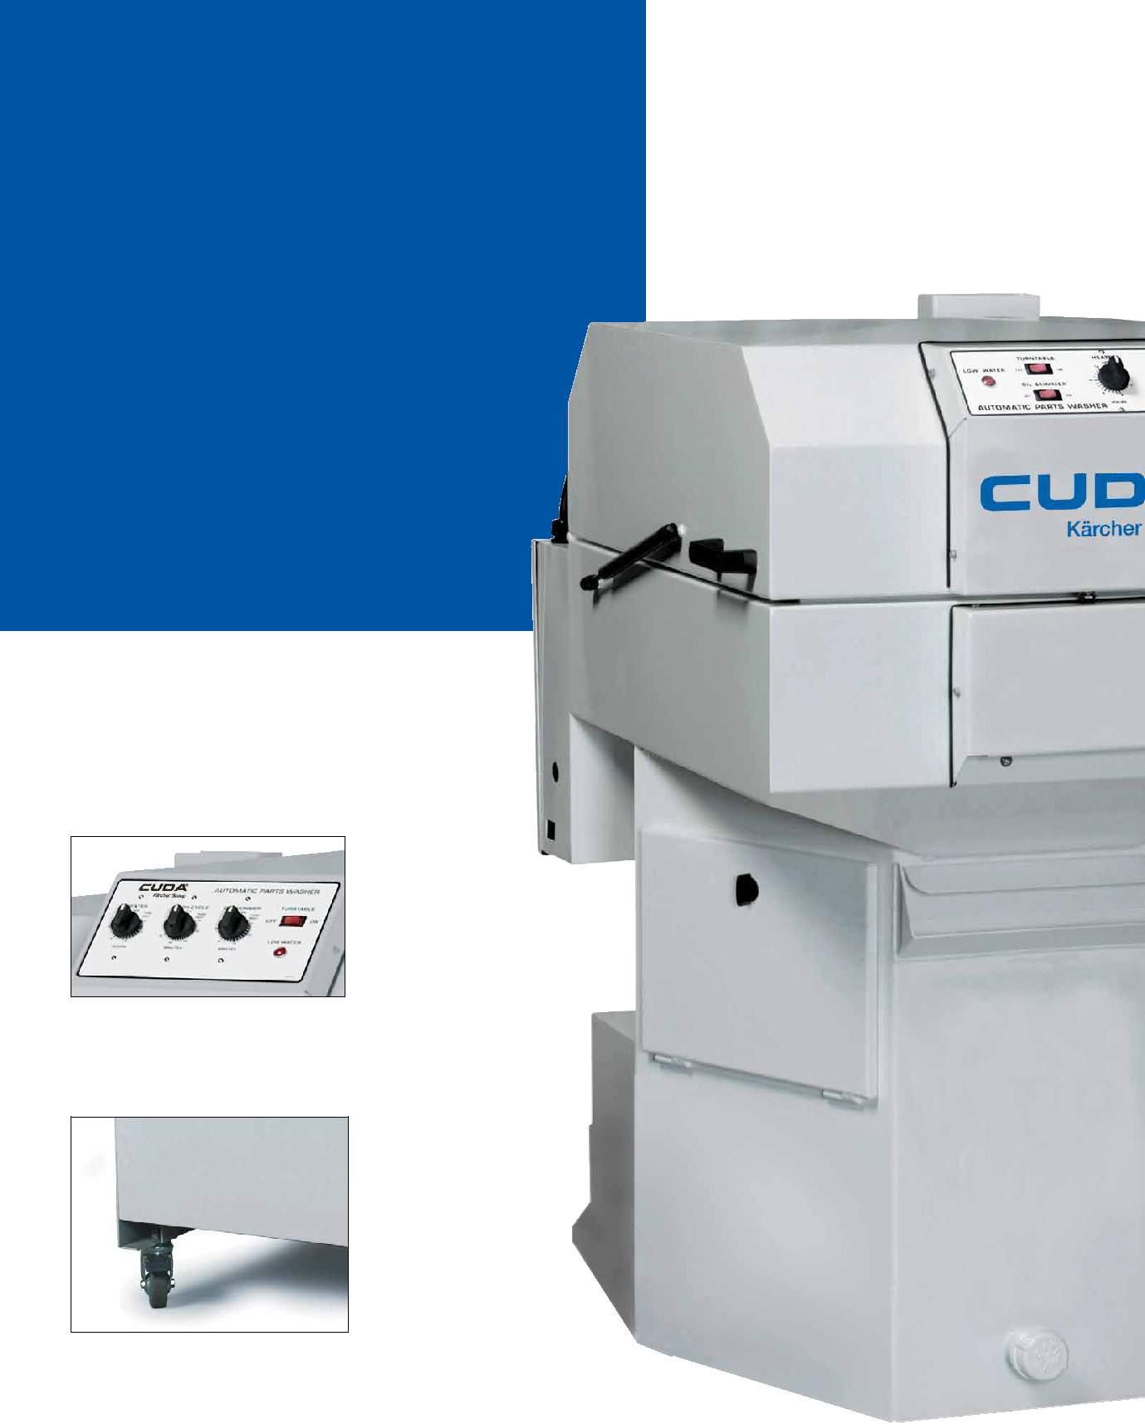
TOP-LOAD AUTOMATIC AQUEOUS PARTS WASHERS | FEATURES & BENEFITS

SIMPLY EFFICIENT

Our line of

automatic aqueous parts washers

has provided a safe and time-saving

cleaning solution for thousands of

repair shops and other businesses for

over 25 years. The many standard

and optional features available with

your Cuda are all designed to save

you time and money.

Control panel has simple controls

for heater, turntable and wash-cycle

operation, as well as a low water

shut-off indicator.

Optional built-in wheels allow the parts washer to be moved easily about the shop.

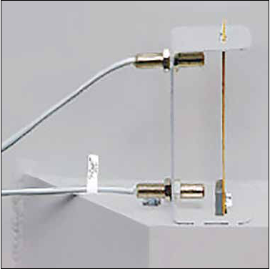

Automatic low-water shutoff (standard all models) enhances safety and protects heating element by automatically turning the unit off if the water level drops too low.
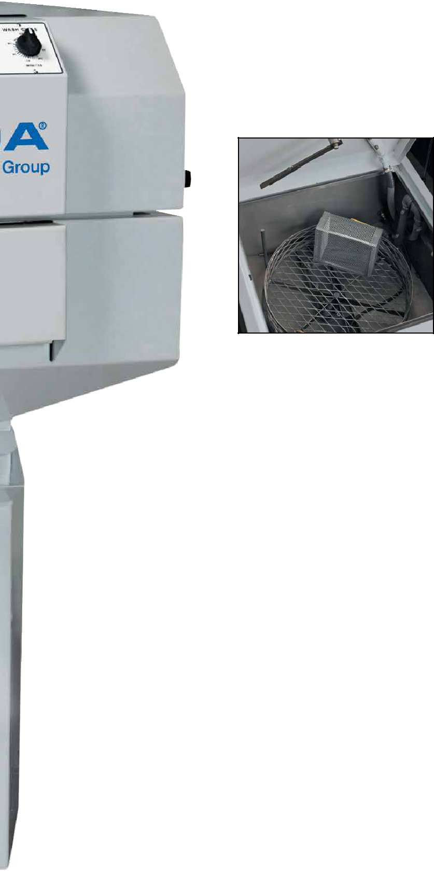

Upper drive arm rotates the turntable (shown with optional small parts basket and containment ring).
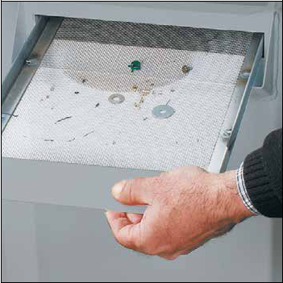

Removable debris screen (standard all models) prevents small particles and loose parts from entering the cleaning solution, ensuring blockage-free spray-nozzle operation.

Optional detail brush with pump and pneumatic power brush enhance the scouring reach for stubborn gasket materials and carbon deposits (both require shop air).
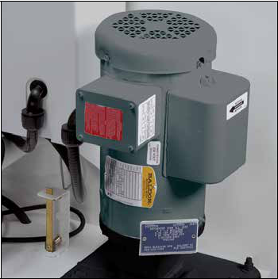
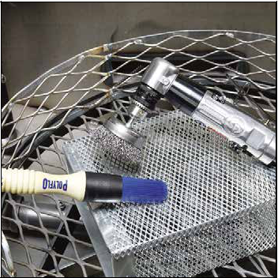

Vertical seal-less pump — positive flow and no vibrations; easy to service when needed.
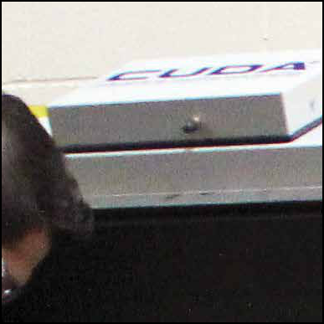

Momentary safety switch automatically turns off pump when lid is opened to protect operator from hot-water spray.

Easy-access sump cover permits quick and easy cleaning of the aqueous parts washer.
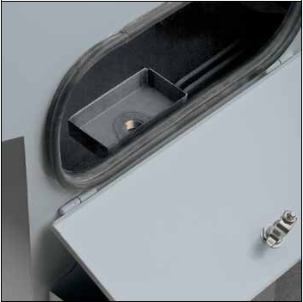
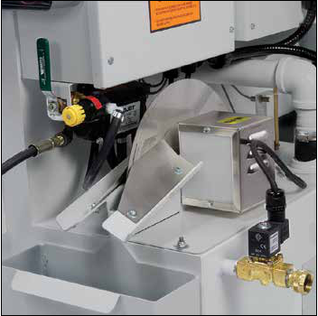

Built-in oil skimmer (standard all models) and optional oil drain container removes & collects oil from cleaning solution in sump.
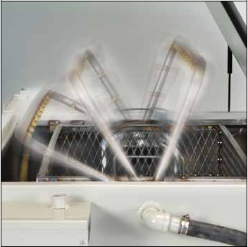

SJ-15 water-propelled spinning spray bar has

23 precision spray nozzles so parts are hit from every angle, creating a surround cleaning effect.

Designed for Safety, all standard models are ETL-Certified to the UL-73 standards. The ETL certification is proof that your Cuda has been independently tested and is in compliance to North American safety standards.

CUDA KÄRCHER GROUP | TOP-LOAD AUTOMATIC AQUEOUS PARTS WASHERS

TOP-LOAD AUTOMATIC PARTS WASHERS
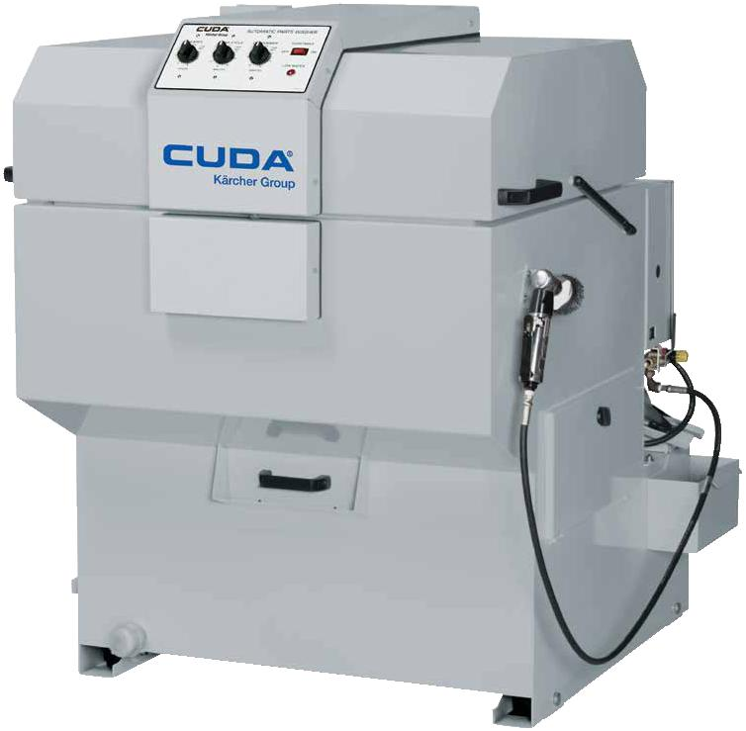

Small in size, yet big in their cleaning power!

Top-load parts washers use pressurized hot water and specialized industrial detergents with

rust inhibitors to clean parts automatically – increasing productivity and saving money while protecting your workers from nasty solvents and manual scrubbing. Compact in size, yet able to accommodate and clean parts up to 500 pounds. Our top-load series parts washers have many standard and optional features like a rotating turntable or water-propelled spray arm, automatic low-water shutoff protection, disc oil skimmer, caster wheels, steam venting, easy-lift lid with gas struts and debris prevention screens. Four mild steel series are available in a variety of electrical configurations. Our top-load parts washers are ideal for any industry cleaning small-to medium-sized parts.

• Choose from Four Series Models • Load Capacity 250 to 500 Lbs.
• .5 HP to 3 HP Close Coupled, Sealed or Vertical, Seal-less Pump

• 20 to 50 GPM @ 22 to 45 PSI

• Sump Capacity 23 to 90 Gallons

• 115V, 208V, 230V, 460V, and 575V Configurations
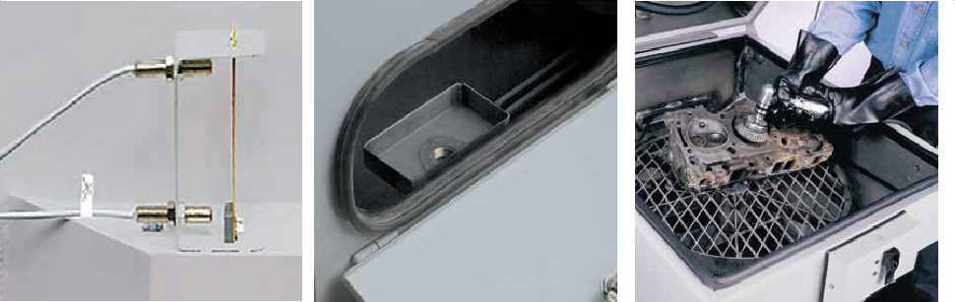

1 |  |  | 2 |  |  | 3 |  |  | 4
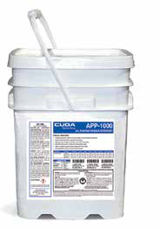

- Automatic low-water shutoff

■■ Safeguards heating element from undue wear.

■■ Instantly turns the parts washers off if the water level drops too low.

- Customize and Accessorize

■■ Customize your parts washer to tailor to your specific needs and washing will become the easiest part of the work day.

2 | Sump Cover

■■ Easy open cover makes simple work of cleaning the parts washer.

■■ Prevents external debris from entering the sump.

TECHNICAL DATA AND EQUIPMENT
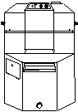
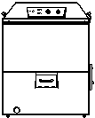
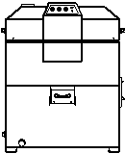
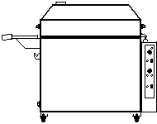

 | 2412 SERIES | 2216 SERIES | SJ SERIES | 2518 SERIES
Working Height | 12" | 16" | 18" | 18"
Turntable Diameter | 24" | 22" | 32 x 21" | 25"
Turntable Load Cap* | 250 lbs | 500 lbs | 350 lbs | 500 lbs
Pump Motor | 1/2 HP | 1 HP | 3 HP | 3 HP
Pump Capacity | 20 GPM / 22 PSI | 28 GPM / 30 PSI | 50 GPM / 45 PSI | 50 GPM / 45 PSI
Sump Capacity | 25 gal | 23 gal | 90 gal | 50 gal
Electric Heater | 1.8kw / 4.5 kW | 1.8kw / 4.5 kW | 6 kW | 6 kW
Operating Temp | 150° — 170° | 150° — 170° | 150° — 170° | 150° — 170°
Electrical | 115 / 1 / 15 | 115 / 1 / 15 | — | —
(Volts / Phase / Amps)
 | 208 / 1 / 26 | 208 / 1 / 30 | 208 / 1 / 42 | 208 / 1 / 39
 | — | 208 / 3 / 21 | 208 / 3 / 25 | 208 / 3 / 25
 | 230 / 1 / 24 | 230 / 1 / 28 | 230 / 1 / 38 | 230 / 1 / 38
 | — | 230 / 3 / 20 | 230 / 3 / 23 | 230 / 3 / 23
 | — | 460 / 3 / 10 | 460 / 3 / 11 | 460 / 3 / 11
 | — | 575 / 3 / 8 | 575 / 3 / 9 | 575 / 3 / 9
Dimensions (L x W x H) | 41" x 35" x 45" | 42" x 32" x 52" | 51" x 48" x 49" | 51" x 40" x 50"
Stainless Steel Models** | ■ | ■ | — | ■

*Load capacity was determined with even weight distribution **Series also available in stainless steel with standard cast pump.

Standard Accessories

Preferred Options Package | Contains Small Parts Basket, Containment Ring, Oil-Drain Container

Optional Accessories
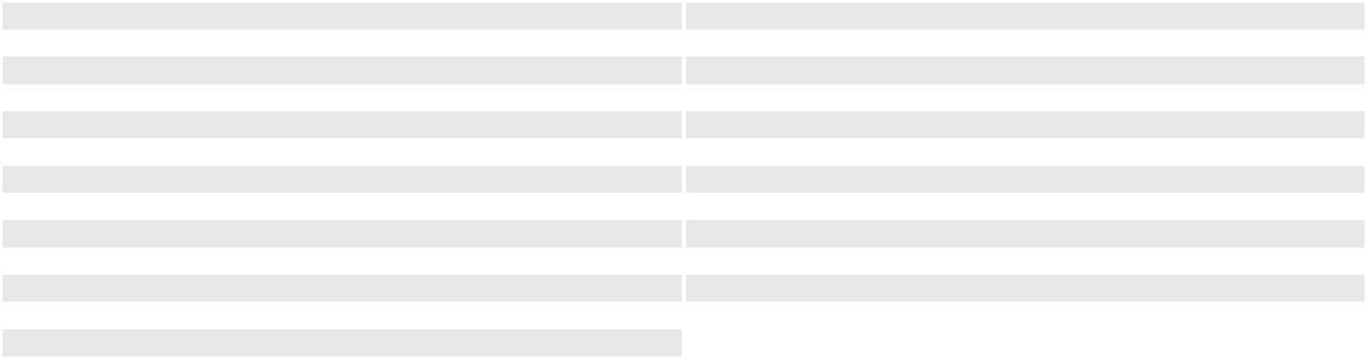

Automatic Water Fill | Service Tray ‡
Containment Ring † | Tool Basket with Tools (includes 3 brushes, 1 scraper) ‡
Filtration | Oil Drain Container
Filtration & Sump Sweep (2518 Series Only) | Hour Meter
60 Mesh for Debris Screen Tray Insert | PK-100D Sump Cleaner
Heater Timer 24 hour 7 day | PK-100D Filter Bag †
Heater Timer & Skimmer 24 hour 7 day † | Wastewater Drum Evaporator Belt
Deluxe Kit: Detail and Power Brush | Light Duty Small Parts Basket (8" x 8" x 4")
Detail Brush with Pump | Lid for Light Duty Small Parts Basket
Pneumatic Power Brush | Light Duty Medium Parts Basket (16" x 12" x 6")
Pressure Gauge ‡ | Lid for Light Duty Medium Parts Basket
Temperature Gauge ‡ | Gray Spray Paint
Caster Wheels, Set of 4 ‡
† Not available for SJ Series ‡ SJ Series Only

