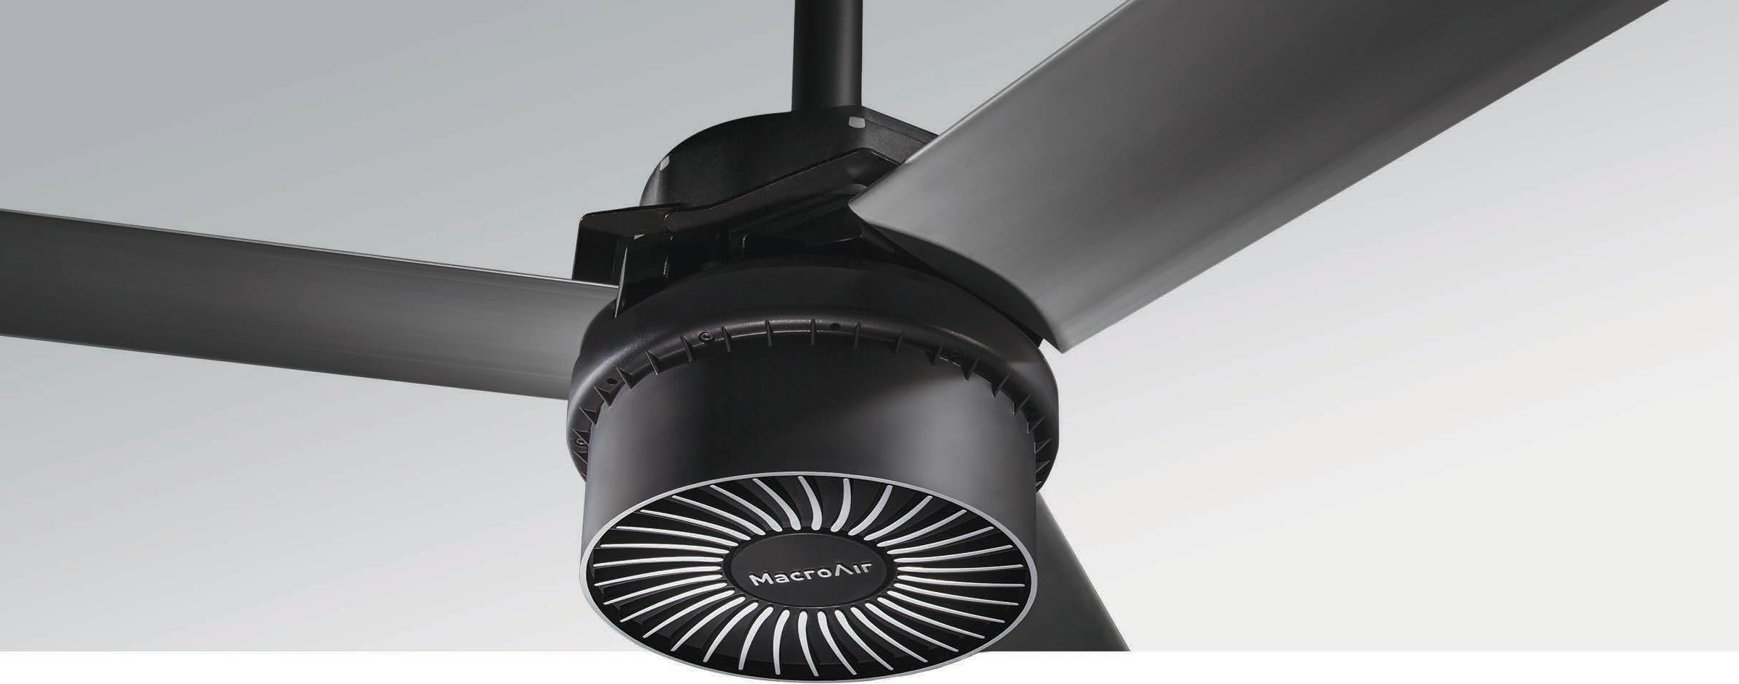

Medium to Large Spaces
The AirVolution-D3 is ideally suited for medium to large spaces such as car dealerships, manufacturing facilities, and distribution warehouses. Designed to be our most cost-eﬀective HVLS fan, this model incorporates the primary benefits of our gearless technology. It features the highest eﬃciency motor available, reduced weight, less noise and no maintenance. When high performance, best value and budget are critical factors, the AirVolution-D3 delivers the best ROI of any HVLS fan on the market today.

Key Specs
- Airfoil sizes 10 – 24 ft. integrate into any medium to large space.
- Airfoils also available in black and other customizable colors.
- Custom powder coat paint colors available as well.
- Customizable upgrade options.

- No gearbox means quiet operation and no maintenance.
- Integrates into HVAC and other automated building systems via gateway.
- Wash Down Duty rated for indoor/outdoor use.
- Backed by a 50,000-hour-warranty.

Touchscreen Remote
AirVolutionD3
HVLS Fans by
TM
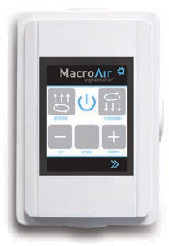
  - 20 speed settings
  - Forward and reverse
  - Integrated warranty hour counter

Warranty
Standard 50,000-hour non- prorated warranty on parts and components. Plus a
1-year warranty on labor.

Mounting Dimensions
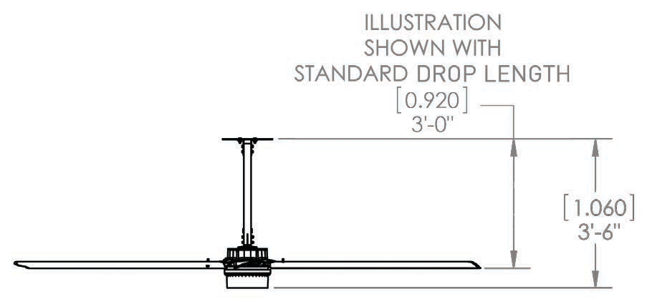Illus ext
tration shown with standard
ension:
ration shown with standard sion

AirVolutionD3
Basic Specifications

HVLS Fans by

TM

Airfoil (Blade) Diameter | 10 ft. | 12 ft. | 14 ft. | 16 ft. | 18 ft. | 20 ft. | 24 ft.
Airfoil Style | 7.375 inch Extruded Anodized Aluminum Airfoils
Number of Airfoils | 3
Performance
Max Speed | 166 RPM | 135 RPM | 118 RPM | 91 RPM | 87 RPM | 81 RPM | 63 RPM
Recommended Spacing * | 55 ft. | 60 ft. | 70 ft. | 75 ft. | 80 ft. | 90 ft. | 95 ft.
Sound Level dBA at Max Speed * * | 56 | 55 | 54 | 52 | 52 | 54 | 51
Hanging Requirements
Hanging Weight | 129 lbs | 133 lbs | 137 lbs | 141 lbs | 145 lbs | 149 lbs | 162 lbs
Max Torque | 16 lbf/ft | 22 lbf/ft | 29 lbf/ft | 32 lbf/ft | 42 lbf/ft | 53 lbf/ft | 53 lbf/ft
Max Thrust in Reverse | 7 lbs | 10 lbs | 13 lbs | 15 lbs | 19 lbs | 22 lbs | 20 lbs
Motor and Drive Train
Motor Type | Gearless Direct Drive
Equivalent Horsepower Rating | 1.05 HP
Operating Temp Range | 16ºF (-10ºC) – 140ºF (60ºC)
Max Amp Draw / Recommended Fuse
208-240 VAC 1-Phase | 3.5A / 5 | 3.7A / 5 | 4.3A / 5 | 3.2A / 5 | 4.5A / 5 | 5.7A / 10 | 6A / 10
208-240 VAC 3-Phase | 2.5A / 5 | 2.6A / 5 | 2.9A / 5 | 2.4A / 5 | 3A / 5 | 3.6A / 5 | 3.8A / 5
480 VAC 3-Phase | 1.1A / 5 | 1A / 5 | 1.3A / 5 | 1A / 5 | 1.3A / 5 | 1.8A / 5 | 1.7A / 5
Power & Controls
Power Source High | Three Phase (380-480) VAC +/-5%, 50/60 Hz
Power Source Low | Single Phase or Three Phase (208-240) VAC +/-5%, 50/60 Hz
Control Options | Digital Touchpad Standard, MacroAir Controller 4, 10, 20, 30, AirLynk – BacNet/LonWorks
Installation
Mounting Hardware | Fixed Angle Mount
Drop Length | In addition to the standard drop length supplied, optional drop lengths are available in 1 inch increments.  All drop lengths require guy wires.
Ratings & Compliance
Fire and Sprinkler | NFPA Compliant
Outdoor Rating * * * | Rated for outdoor use.

