TRANSPORTATION | MANUFACTURING

THE SIMPLE CHOICE FOR CLEANING.

Rugged, high-capacity Automatic Parts Washers use pressurized hot water and specialized industrial detergents to safely blast away dirt, grease and grime while you’re doing more productive work. Whether the parts you’re cleaning are big or small, wide or narrow, heavy
or lightweight, we have the automatic parts washer ideal for the job. With load capacities ranging from 500 lbs. to 5,000 lbs., our top-load and front-load models are the simple solution for your parts cleaning applications.

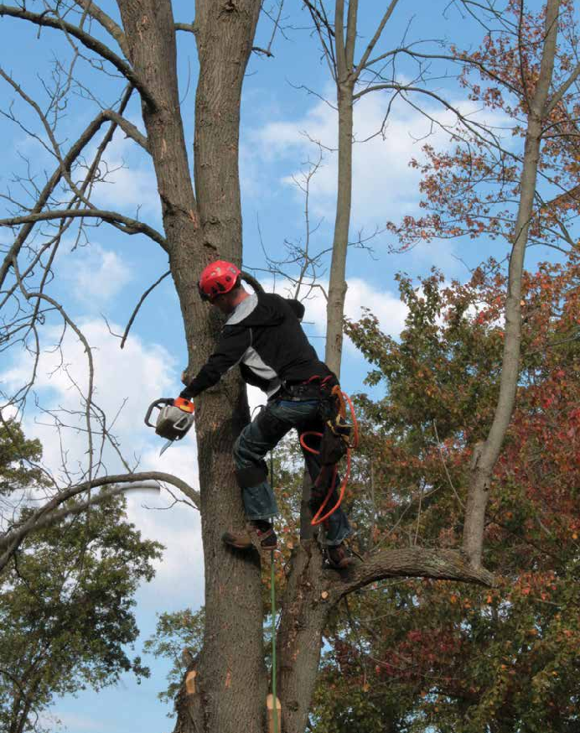
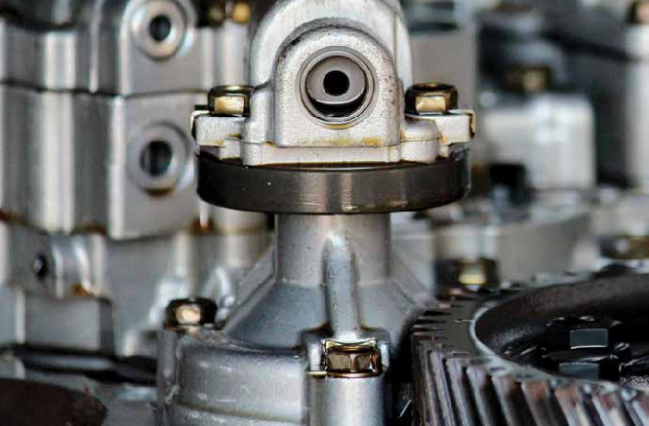
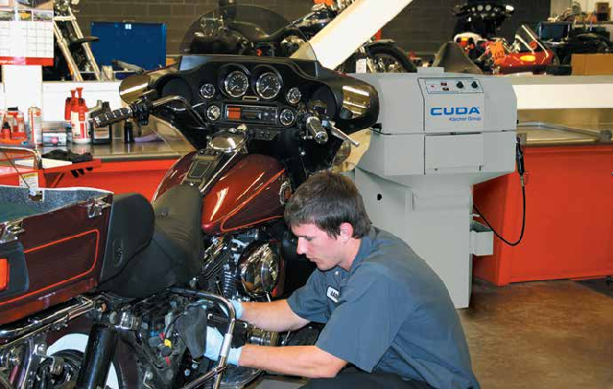
Simple Performance
We specialize exclusively in parts washers and accessories. Our parts washers effectively clean a variety of parts made of metal, plastic and even rubber. These systems are capable of cleaning small parts to large assemblies, limited only by the size of the cabinet itself and are especially effective in removing petroleum products, dirt carbon, and metal shavings.
You can count on us to be the innovators in parts washers. The bottom line is you not only get top performance, you get more standard features and options than with any other brand.

Simply Automatic
Why waste time cleaning parts manually? With our automatic parts washers, you simply load the parts, close the roll-in door and push start. A single one of our parts washers can typically support three to four technicians
or mechanics who would otherwise spend hours washing parts by hand exposed to harmful solvents. Our parts washers allow them to concentrate on jobs that produce income, which means your parts washer could pay for itself in a year or less.

Environmentally Friendly, Safe To Use
Parts washers are based on safe aqueous cleaning, so you eliminate the potential health hazards and disposal problems related to solvent use.

Nationwide Support
When you buy a parts washer from us, you’re assured of timely, professional service and support through our national network of distributors. They can provide you expert advice and support because they specialize exclusively in parts-washing equipment and supplies.

Specialized Detergents
Our detergents are designed specifically for use in our parts washers. We carefully design, blend and manufacture our own detergents to ensure they outperform all other parts cleaning detergents in the industry.

Global Cleaning Leader
Kärcher is recognized globally as a leader in cleaning solutions. In North America, Cuda Kärcher Group automatic parts washers deliver effective, time-saving solutions for professionals.

TRANSPORTATION | MANUFACTURING

BETTER SOLUTIONS

Aqueous parts washers enable manufacturers and fleet operators to speed the cleaning process, whether
it’s on an assembly line or a in washbay. Conservative estimates show that washing parts by hand costs service departments an average of $6,000 a year per technician!
There is a better solution. With our parts washers, technicians can automatically clean anything from the largest engine block to the tiniest bit of hardware, in minutes, with NO hand labor! Powerful spray jets blast
a solution of hot water and biodegradable detergent from the top, bottom and sides, to thoroughly clean the dirtiest parts — freeing the technician to perform other profitable tasks.
Time is money in transportation and manufacturing, and to meet the order demand, you need equipment you can count on.

Automatic parts washers are ideal for cleaning:

- 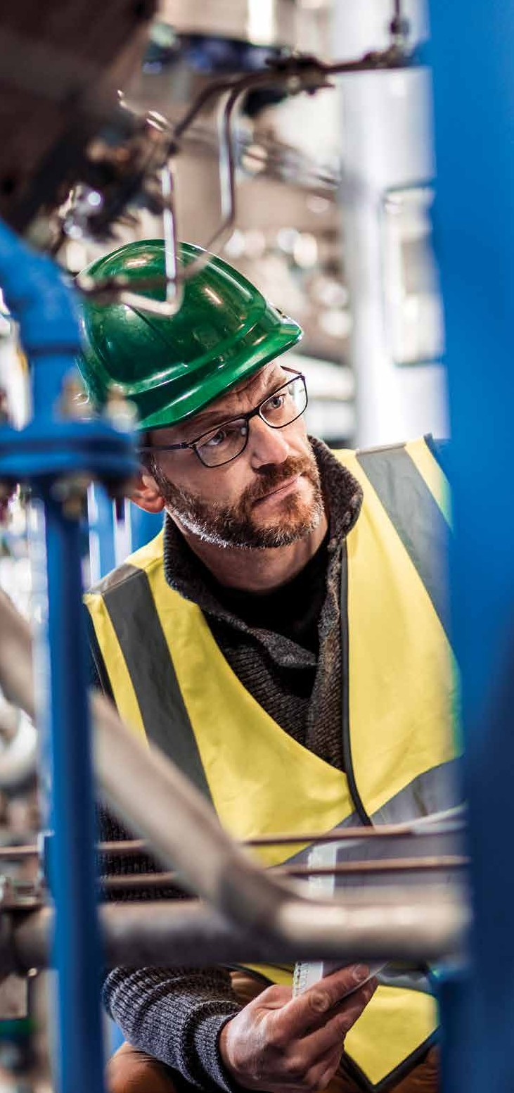Transmissions
- Drivetrain Components
- Fuel Injectors
- Hydraulic Cylinders
- Compressors
- Exhaust Systems
- Chassis Parts
- Engine Blocks & Heads
- Air Compressor Housings
- Brake Master Cylinders
- Fuel Injector Valves and Nozzles
- Turbochargers
- Wheels and Wheel
- Bearings
- Axles
- A/C Components
- Cylinder Heads
- Engine Blocks
- Blower Fans
- Gear Housings
- Carburetors
- Nuts and Bolts
- Pistons
- Guide Bars
- Saw Chains
- Bearings
- Pulleys

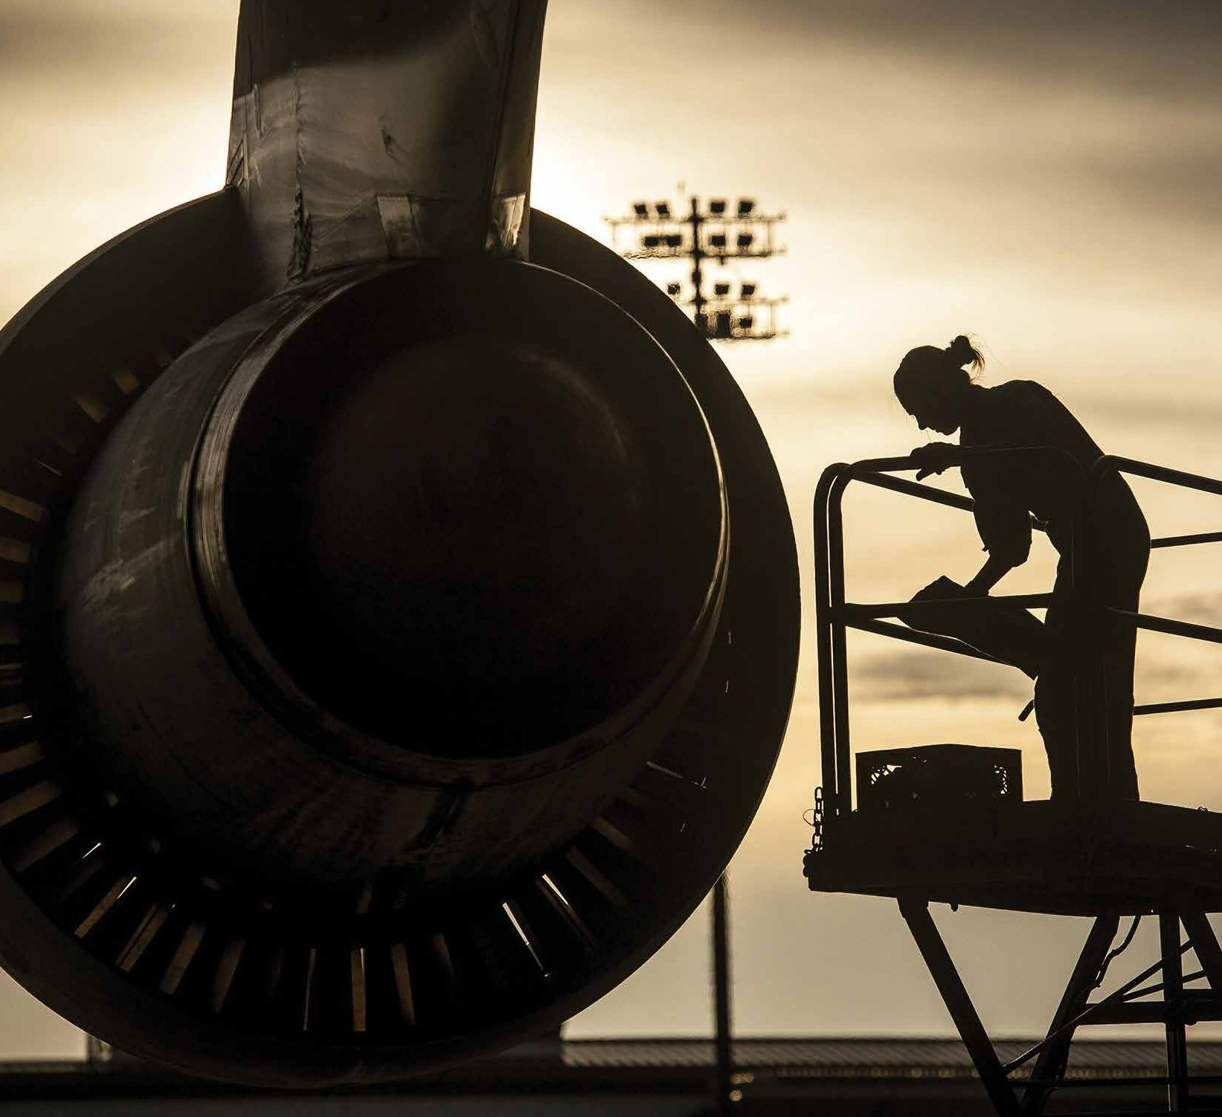
  - Tools
  - Computer Frames and Housings
  - Battery Casings
  - Compressor Parts
  - Metal Furnishings
  - Surgical Implants
  - Aluminum Castings
  - Transformers

- Printing Rollers
- Fittings
- Tooling
- Large Tote Bins
- Moulds
- Sheet-Fed or Web Offset Presses
- Ink Pumps
- Spray Bars

- Slicers
- Cam Followers
- Lever Arms
- Chains
- Bearing Housings
- Brackets
- Roller Washers
- Gears

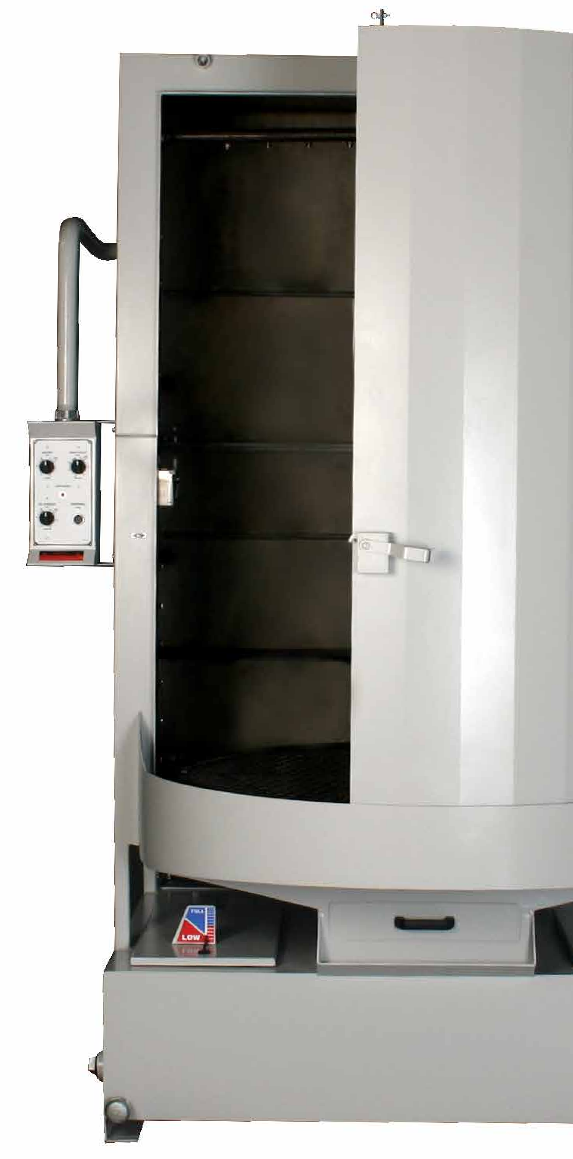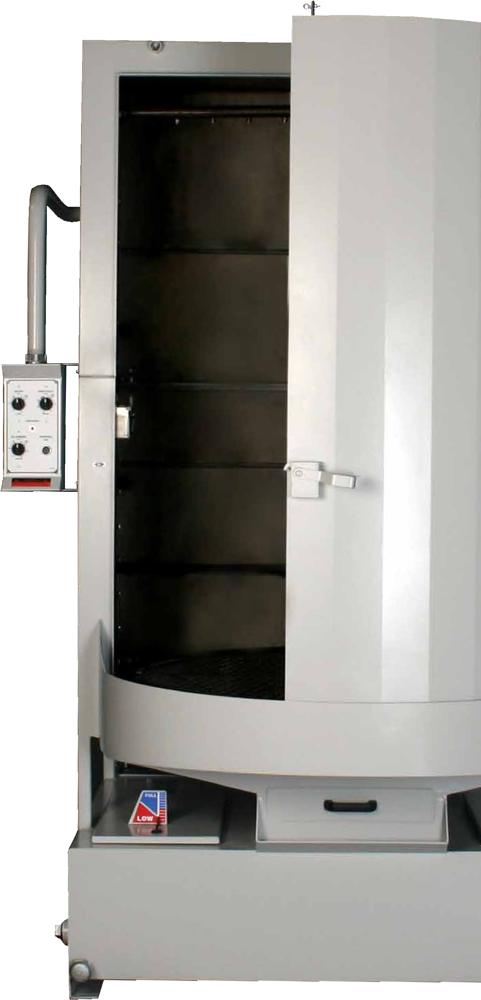FEATURES | BENEFITS

SIMPLY EFFICIENT

Automatic aqueous parts washers have provided a safe
and timesaving cleaning solution for thousands of repair shops and other businesses for over 15 years. The many standard and optional features available with your parts washer are all designed to save you time and money.

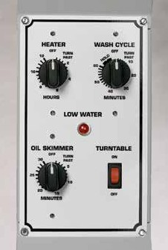Control panel
(all models) includes low-water indicator
light, oil skimmer, heater & wash- cycle timers and turntable ON/OFF switch.
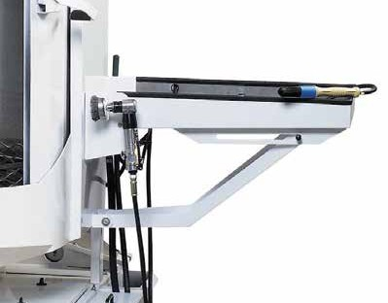
Optional Deluxe Kit (all models) includes a fold-down detail tray, a detail brush that aids in cleaning those delicate or lightly soiled parts and a pneumatic power brush for those pieces that need cleaning attention. A dedicated sump (see below) also is part of the optional Deluxe Kit.

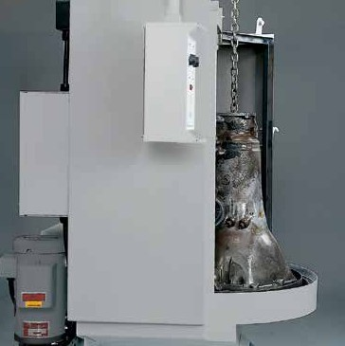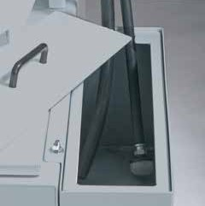

Automatic low-water shutoff (standard all models) enhances safety and protects heating element by automatically turning the unit off if the water level drops too low.
Recessed entry allows easy access to the entire wash area and minimizes stooping and lifting when loading heavy, awkward parts.
Optional dedicated sump is part of the Deluxe Kit and is completely independent of the main sump so it can be filled with any type of cleaning solution.

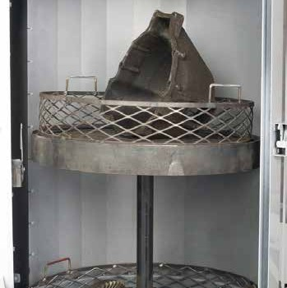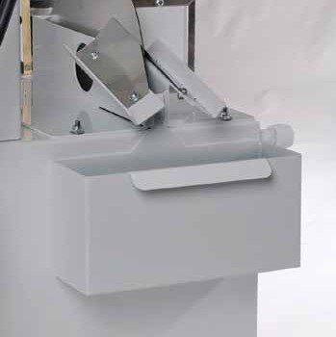

Optional drop-in parts tree slips into a recessed pocket of the turntable. Preferred package also includes small parts basket, containment ring and oil drain container.

Removable Debris Screen (standard all models) prevents small particles and loose parts from entering the cleaning solution, ensuring blockage-free spray-nozzle operation.
Optional two-tier turntable adds second level parts containment for greater parts washing capacity.

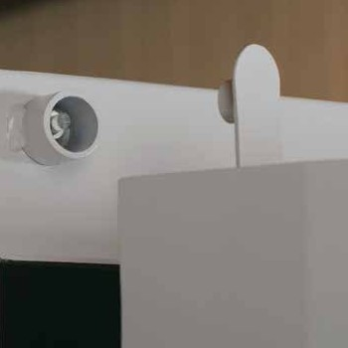Door Safety Switch protects the operator from hot water spray if roll-in door is opened.
Built-in oil skimmer (standard all models) and optional oil drain container removes & collects oil from cleaning solution in sump.

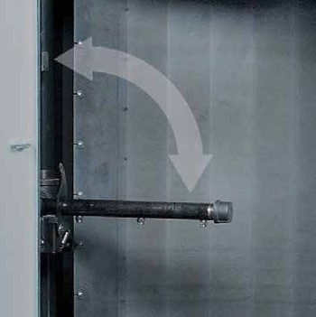
Retractable Intermediate Spray Arm rotates down to clean small parts with or without the optional double-basket.

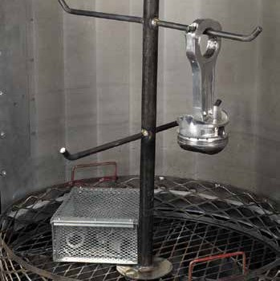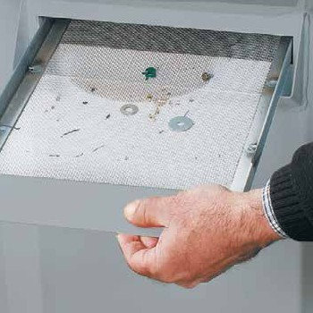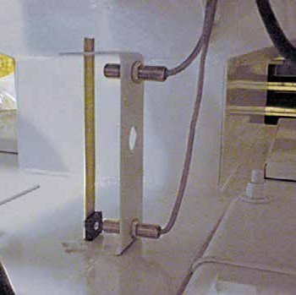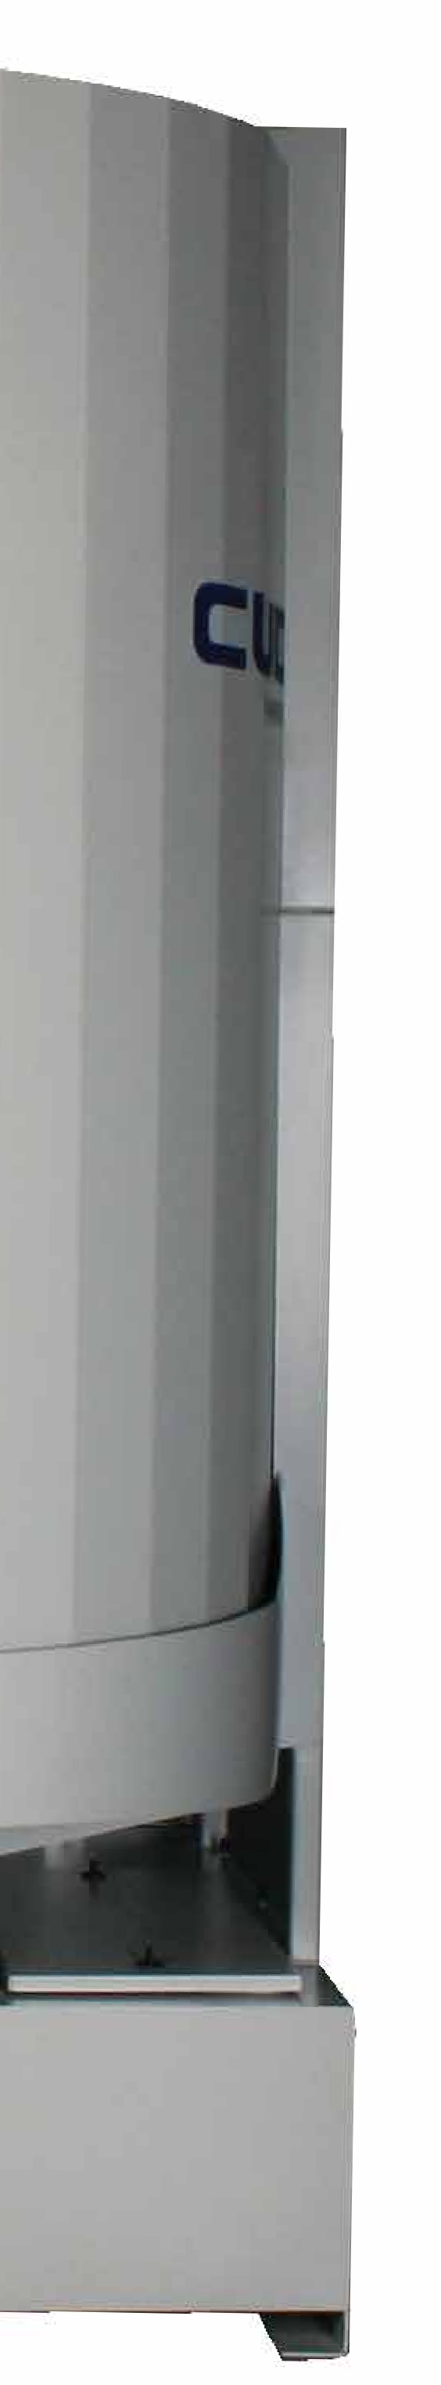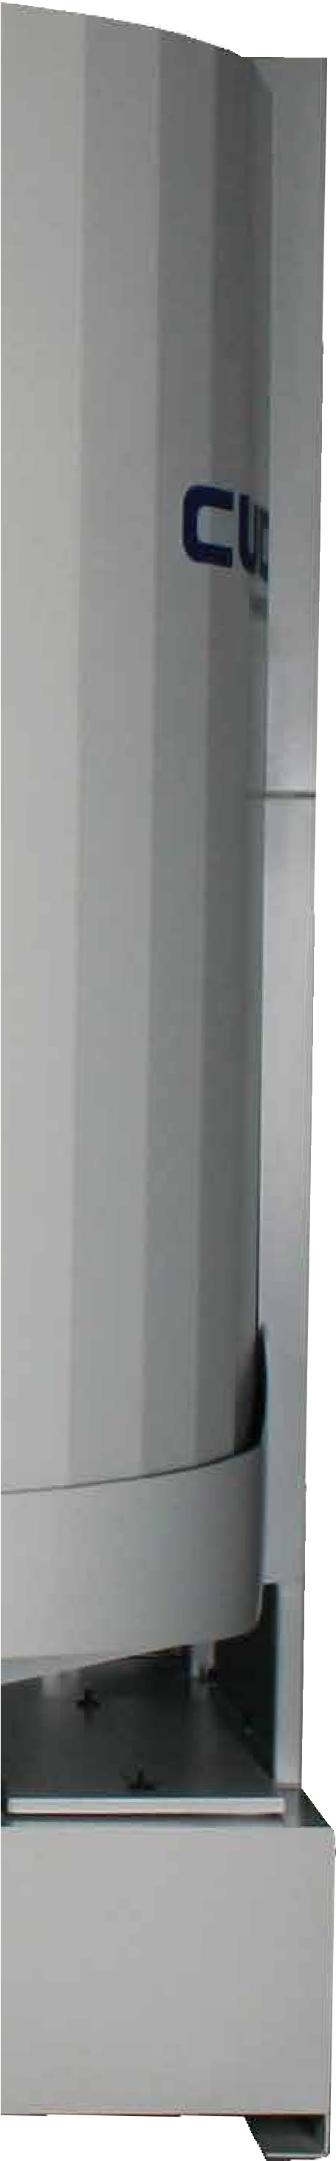
Designed for Safety, all standard models are ETL-Certified to the UL-73 standards. The ETL certification is proof that your Cuda has been independently tested and is in compliance to North American safety standards.

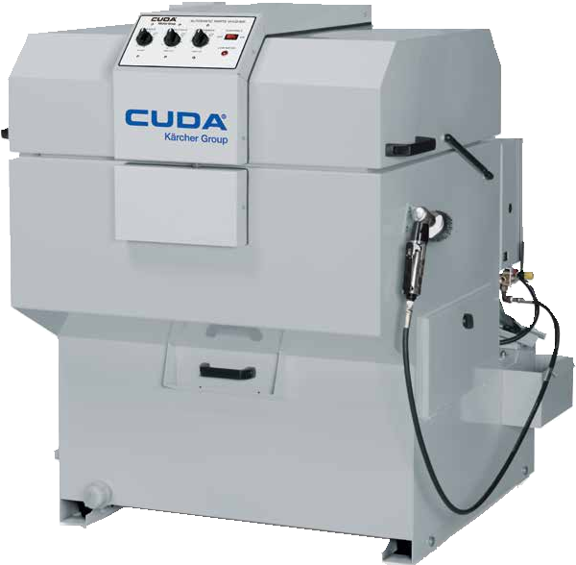
TOP-LOAD | FRONT-LOAD

SMALL IN SIZE,
YET BIG IN THEIR
CLEANING POWER!

Top-Load Machines

Top-load parts washers use pressurized hot water and specialized industrial detergents with rust inhibitors to clean parts automatically – increasing productivity and saving money while protecting your workers from nasty solvents and manual scrubbing. Compact in size, yet able to accommodate and clean parts up to 500 pounds. Our top-load series feature a rotating turntable or water-propelled spray arm, automatic low- water shutoff protection, disc oil skimmer, caster wheels, steam
venting, easy-lift lid with gas struts and debris prevention screens. Four series are available in a variety of electrical configurations.
Top-load parts washers are ideal for any industry cleaning small-to medium-sized parts.

  - Choose from Four Series Models
  - Load Capacity 250 to 500 Lbs.
  - .5 HP to 3 HP Close Coupled. Sealed or Vertical, Seal-less Pump
  - 20 to 50 GPM @ 22 to 45 PSI
  - Sump Capacity 23 to 90 Gallons
  - 115V, 208V, 230V 460V and 575V Configurations

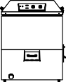
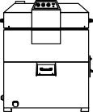

 | 2412 SERIES | 2216 SERIES | SJ SERIES | 2518 SERIES
Working Height | 12" | 16" | 18" | 18"
Turntable Diameter | 24" | 24" | 32 x 21" | 25"
Turntable Load Cap* | 250 lbs | 500 lbs | 350 lbs | 500 lbs
Dimensions (L x W x H) | 45" x 35" x 41" | 52" x 32" x 42" | 49" x 48" x 51" | 50" x 40" x 51"
*Load capacity was determined with even weight distribution

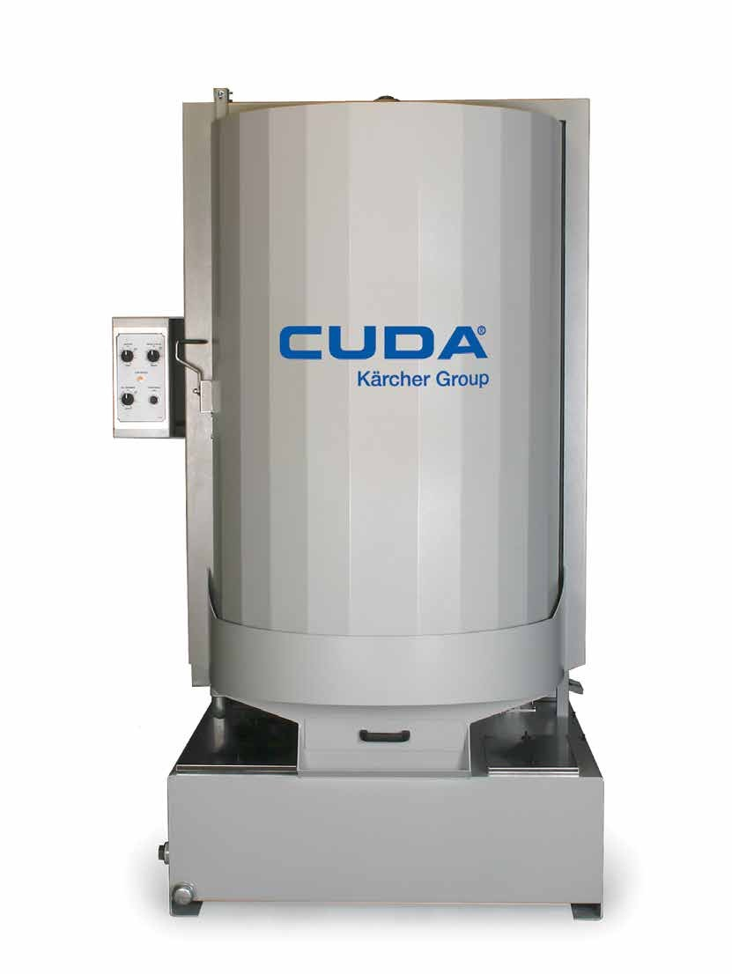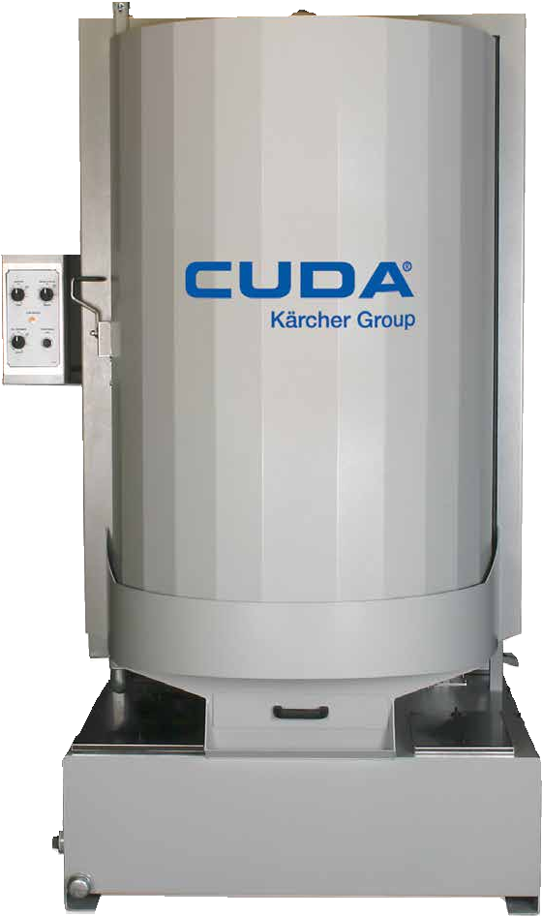

YOUR GO TO CHOICE WHEN BIGGER
CLEANING IS REQUIRED

Front-Load Machines

Capable of up to 5,000 pounds turntable load capacity, front-load parts washers are easy to use. Completely automatic and solvent-free, these rugged “industrial-sized dishwashers” greatly simplify your parts cleaning. Ergonomics and environmental- friendliness blend nicely in our line of front-load parts washers with turntables located knee-high, control panels chest-high, and a curved, recessed entry that allows for easy loading and un-loading. The unique space saving roll-in door design in our front-load parts washers allow easy access to the wash chamber and prevents the wash solution from dripping on the floor. Seven series are available in a variety of electrical configurations. Our front-load parts washers are ideal for any industry cleaning all parts up through even the most extra-large components.

- Choose from Seven Series Models
- Load Capacity 500 to 5,000 Lbs.
- 3 HP to 7.5 HP Vertical, Seal-less Pump
- 50 to 200 GPM @ 45 to 50 PSI
- Sump Capacity 40 to 200 Gallons
- 208V, 230V, 460V, and 575V Configurations

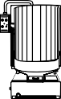
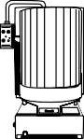
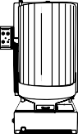
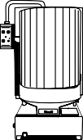
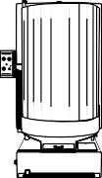
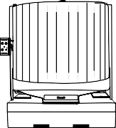
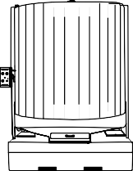

 | 2530 SERIES | 2840 SERIES | 2848 SERIES | 3648 SERIES | 4860 SERIES | 7248 SERIES | 7272 SERIES
Working Height | 30" | 40" | 48" | 48" | 60" | 48" | 72"
Turntable Diameter | 25" | 28" | 28" | 36" | 48" | 72" | 72"
Turntable Load Cap* | 500 lbs | 1000 lbs | 1000 lbs | 2500 lbs | 5000 lbs | 5000 lbs | 5000 lbs
Dimensions (L x W x H) | 45" x 48" x 74" | 50" x 51" x 80" | 50" x 51" x 88" | 49" x 57" x 94" | 66" x 75" x 106" | 100" x 85" x 100" | 100" x 85" x 126"
*Load capacity was determined with even weight distribution

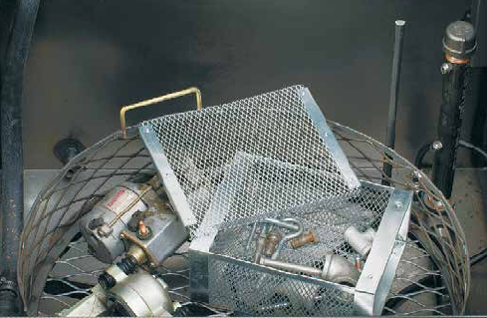

CUSTOMIZE AND ACCESSORIZE

Customize your parts washer to tailor to your specific needs and washing will become the easiest part of the work day.

  - Automatic Water Fill connects directly to a water line to automatically keep the water level at the optimum level.
  - 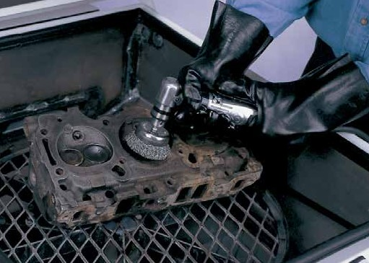Turntable Containment Rings are heavy-duty rings constructed of expanded metal and encircle the entire turntable to keep parts from falling off and jamming the drive.
  - Detail Brush is designed for hand detailing, the optional cleaning brush is located inside the wash cabinet in top-load models, and outside on the tray in front-load models, and uses the cleaning solution from the washer reservoir.
  - Power Pneumatic Brush is powerful and practical tool that will clean all of the toughest jobs, including burnt on carbon, adhesives, gasket material, etc.
  - 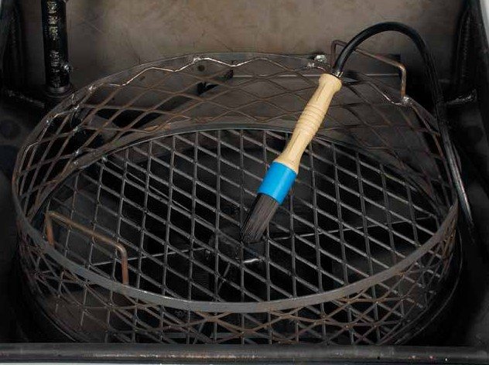Small and large parts baskets parts save time and frustration when cleaning a wide variety of small parts. The light-duty parts basket is perfect for nuts, bolts and other small fasteners.
Heavy-duty parts baskets keep parts separate from others.
  - Parts Trees & Posts are for front-load machines to lean, chain or hook parts onto to keep them in optimum cleaning position.
  - Oil Drain Containers are engineered to fit tight against the washer and are removable for easy draining and disposal.
  - Two-Tier Turntables are removable and can double the cleaning area of your washer when cleaning small parts.
  - Timers are available to control heat up times and oil removal. 24-hour, 7-day timers are not only convenient they will usually pay for themselves with reduced energy consumption.
  - Filtration is essential for potential high solids customers. Bag filtration can extend the useful life of the cleaning solution and prevent re-depositing of particulate back onto clean parts.
  - Sump Sweep is an exclusive filtration option ideal for high solids cleaning applications such as off road equipment, oil field equipment, and many others. This revolutionary design features an L-shaped spray bar in the sump. A three-way ball valve allows you to “sweep” the tank bottom with pressure from the wash pump. This moves the heavy solids toward the wash pump inlet and into the filter, localizing into the filter bag.

