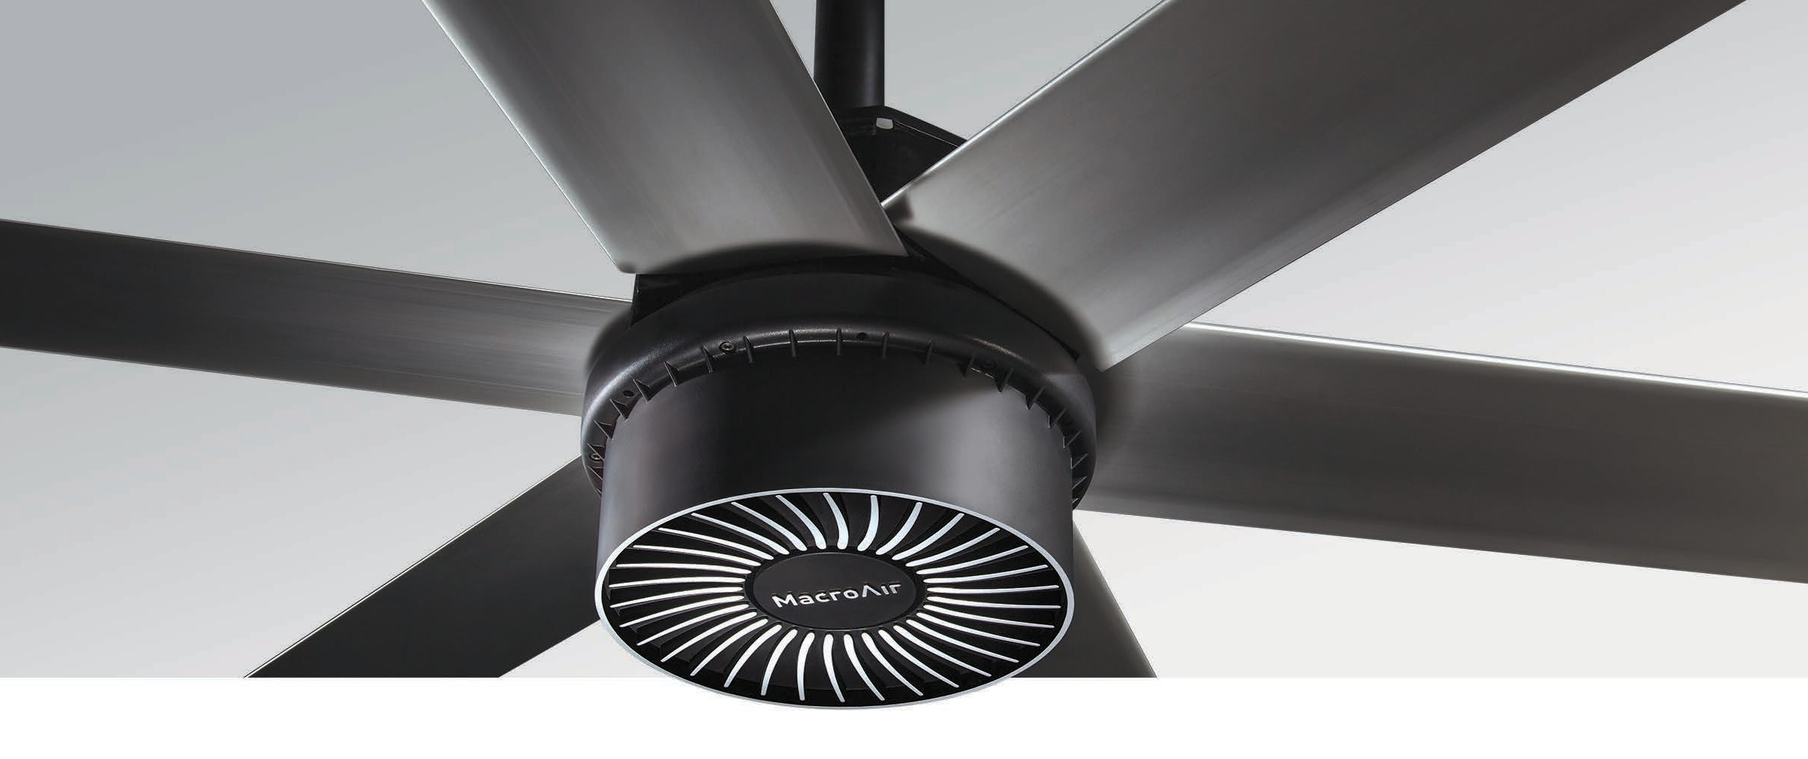
Medium to Large Spaces
For medium to large spaces, the AirVolution-D 550 fan is extremely eﬀective at controlling temperature and humidity. Ideal locations include auto shops, gyms, and agricultural applications. The system design eliminates the gearbox for a lighter, leak-proof fan that is durable and runs with less friction. This design makes it easy to install, maintenance-free, and practically inaudible. The full line is also wash down rated for indoor or outdoor use.

Key Specs
- Airfoil sizes 8 –18 ft. integrate into any medium to large space.
- Airfoils also available in black and other customizable colors.
- Lighter for easy installation, less wear and tear.
- 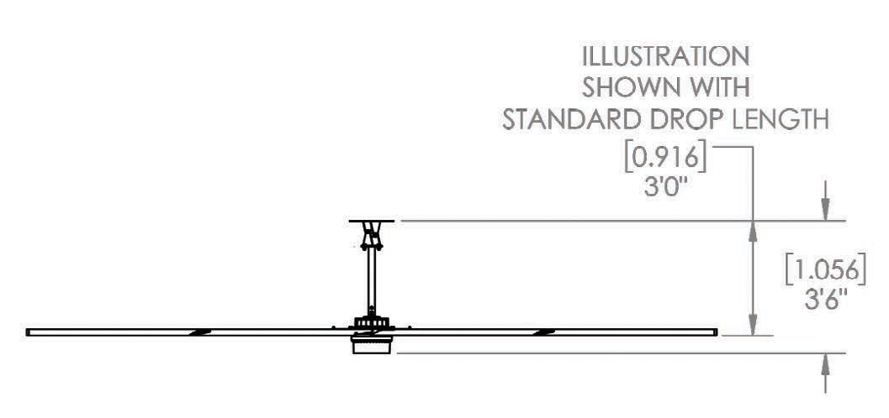On-board AirBrain adapts to input voltages, optimizes motor control.
Illustration shown with standard
extension:
llustration shown with standard extension

- No gearbox means quiet operation and no maintenance.
- Integrates into HVAC and other automated building systems via gateway.
- Wash Down Duty rated for indoor/outdoor use.
- Backed by a 50,000-hour-warranty.

Touchscreen Remote
AirVolution-D 550
HVLS Fans by
TM
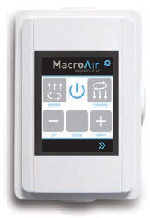
  - 20 speed settings
  - Forward and reverse
  - Integrated warranty hour counter

Warranty
Standard 50,000-hour non- prorated warranty on parts and components. Plus a
1-year warranty on labor.

Mounting Dimensions

AirVolution-D 550
Basic Specifications

HVLS Fans by

TM

Airfoil (Blade) Diameter | 8 ft. | 10 ft. | 12 ft. | 14 ft. | 16 ft. | 18 ft.
Airfoil Style | 7.375 inch Extruded Anodized Aluminum Airfoils
Number of Airfoils | 6
Performance
Max Speed | 220 RPM | 170 RPM | 137 RPM | 110 RPM | 90 RPM | 74 RPM
Recommended Spacing * | 60 ft. | 65 ft. | 70 ft. | 80 ft. | 90 ft. | 95 ft.
Sound Level dBA at Max Speed * * | 61 | 59 | 60 | 56 | 53 | 53
Hanging Requirements
Hanging Weight | 144 lbs | 153 lbs | 162 lbs | 172 lbs | 180 lbs | 188 lbs
Max Torque | 20 lbf/ft | 28 lbf/ft | 36 lbf/ft | 44 lbf/ft | 55 lbf/ft | 58 lbf/ft
Max Thrust in Reverse | 4 lbs | 8 lbs | 12 lbs | 17 lbs | 22 lbs | 22 lbs
Motor and Drive Train
Motor Type | Gearless Direct Drive
Equivalent Horsepower Rating | 1.05 HP
Operating Temp Range | 16ºF (-10ºC) – 140ºF (40ºC)
Max Amp Draw / Recommended Fuse
110 VAC Single Phase | 9A / 10 | 13.9A / 15 | 13.9A / 15 | 13.9A / 15 | 15.2A / 20 | 15.2A / 20
120 VAC Single Phase | 8.3A / 10 | 12.7A / 15 | 12.7A / 15 | 12.7A / 15 | 14A / 15 | 14A / 15
208-240 VAC Single Phase | 4.8A / 5 | 7.3A / 10 | 7.3A / 10 | 7.3A / 10 | 8.1A / 10 | 8.1A / 10
208-240 VAC Three Phase | 3.4A / 5 | 5.3A / 10 | 5.3A / 10 | 5.3A / 10 | 6.6A / 10 | 5.8A / 10
380 VAC Three Phase | 1.9A / 5 | 2.9A / 5 | 2.9A / 5 | 2.9A / 5 | 3.6A / 5 | 3.2A / 5
480 VAC Three Phase | 1.5A / 5 | 2.3A / 5 | 2.3A / 5 | 2.3A / 5 | 2.9A / 5 | 2.5A / 5
600 VAC Three Phase | 1.2A / 5 | 1.8A / 5 | 1.8A / 5 | 1.8A / 5 | 2.3A / 5 | 2A / 5
Power & Controls
Power Source High | Three Phase (380-600) VAC +/-5%, 50/60 Hz
Power Source Low | Single Phase or Three Phase (120-240) VAC +/-5%, 50/60 Hz
Control Options | Digital Touchpad Standard, MacroAir Controller 4, 10, 20, 30, AirLynk – BacNet/LonWorks
Installation
Mounting Hardware | Universal Mount
Drop Length | In addition to the standard drop length supplied, optional drop lengths are available in 1 inch increments.  Guy wires required with Universal Mount; with Rapid Mount guy wires are optional.
Ratings & Compliance
Fire and Sprinkler | NFPA Compliant
Outdoor Rating * * * | Rated for outdoor use.
Certifications | UL 507, CE

