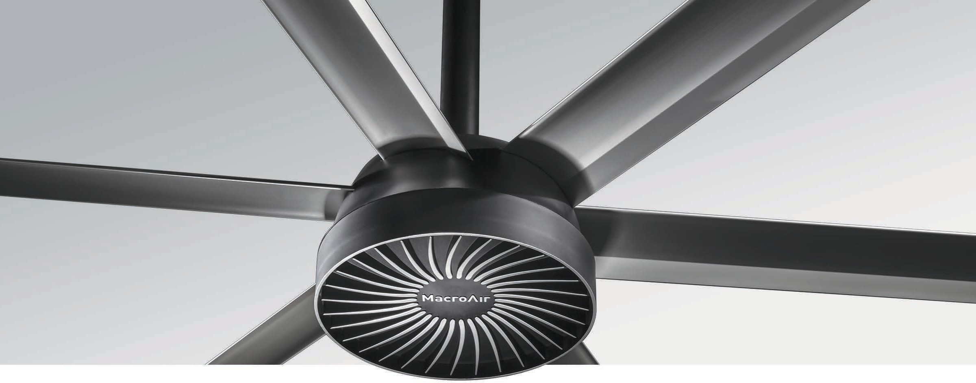

Small Space Solution
Ideal for ceiling heights as low as 12 ft, the AirVolution-D 370 is remarkably quiet. Its next generation motor design eliminates the gearbox, resulting in reduced noise, zero maintenance, and easy installation. Sleek looks and custom color options add to its appeal, allowing it to blend with any setting. For small spaces like oﬃces, restaurants and lobbies, the AirVolution-D 370 is a perfect fit.

Key Specs
- Airfoil sizes 6 to 12 ft. integrate into any small space.
- Airfoils also available in black and oak woodgrain.
- On-board AirBrain optimizes motor control.

- No gearbox means quiet operation and no maintenance.
- Wash Down Duty rated for indoor/outdoor use.
- Backed by a 50,000-hour-warranty.

Touchscreen Remote
AirVolution-D 370
HVLS Fans by
TM
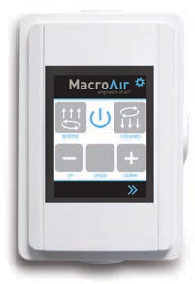
  - 20 speed settings
  - Forward and reverse
  - Integrated warranty hour counter

Warranty
Standard 50,000-hour non- prorated warranty on parts and components. Plus a
1-year warranty on labor.

Mounting Dimensions
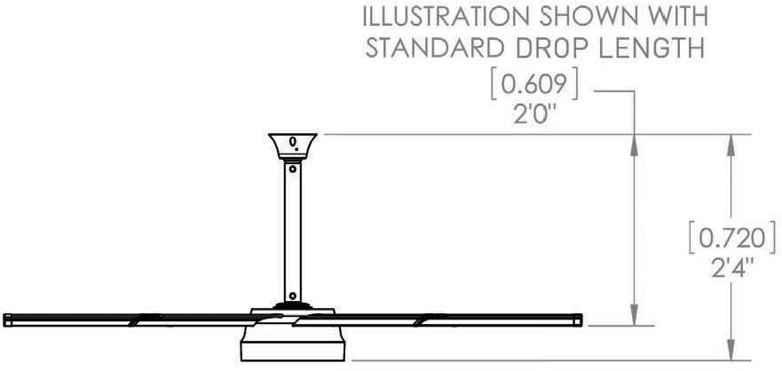
Illustration shown with standard extension:

AirVolution-D 370
Basic Specifications

HVLS Fans by

TM

Airfoil (Blade) Diameter | 6 ft. | 8 ft. | 10 ft. | 12 ft.
Airfoil Style | 4.5 inch Extruded Anodized Aluminum Airfoils
Number of Airfoils | 6
Performance
Max Speed | 140 RPM | 140 RPM | 93.5 RPM | 65.2 RPM
Recommended Spacing * | 28 ft. | 36 ft. | 40 ft. | 48 ft.
Sound Level dBA at Max Speed * * | 40 | 48 | 44 | 41
Hanging Requirements
Hanging Weight | 52 lbs. | 59 lbs | 65 lbs | 74 lbs
Max Torque | 4 lbf/ft | 10 lbf/ft | 10 lbf/ft | 11 lbf/ft
Max Thrust in Reverse | 2 lbs | 3 lbs | 4 lbs | 4 lbs
Motor & Drive Train
Motor Type | Gearless Direct Drive
Equivalent Horsepower Rating | 0.25 HP
Operating Temp Range | 16ºF (-10ºC) – 122ºF (50ºC)
Max Amp Draw / Recommended Fuse
110 VAC 1-Phase | 1.5A / 5 | 5.9A / 10 | 3.8A / 5 | 2.0A / 5
120 VAC 1-Phase | 1.4A / 5 | 5.4A / 10 | 3.5A / 5 | 1.8A / 5
208 VAC 1-Phase | 0.8A / 5 | 3.1A / 5 | 2.0A / 5 | 1.0A / 5
Power & Controls
Power Source Low | Single Phase (110 or 220) VAC +/-5%
Control Options | Digital Touchpad Standard, MacroAir Controller 4, 10, 20, 30, AirLynk – BacNet/LonWorks
Installation
Mounting Hardware | Rapid Mount Commercial
Drop Length | In addition to the standard drop length supplied, optional drop lengths are available in 1 inch increments.  Total drop lengths 5 feet and greater require Fixed Angle Mount with guy wires.
Ratings & Compliance
Fire and Sprinkler | NFPA Compliant
Wash Down Duty Rating | Rated for outdoor use.
Certifications | UL 507, CE

