UDA KÄRCHER GROUP | FRONT-LOAD AUTOMATIC AQUEOUS PARTS WASHERS

THE SIMPLE
CHOICE FOR

CLEANING.

Rugged, high-capacity Automatic Parts Washers use pressurized hot water and specialized industrial detergents to safely blast away dirt, grease and grime while you’re doing more productive work. Whether the parts you’re cleaning are big or small, wide or narrow, heavy or lightweight, we have the automatic parts washer ideal for the job. With load capacities ranging from 500 to 5,000 lbs. and a space saving footprint, our front-load models are the simple solution for your parts cleaning applications.

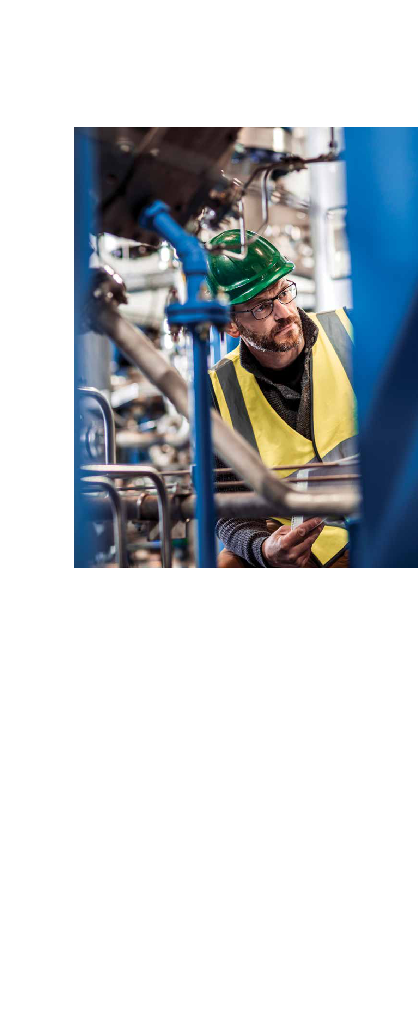

Simple Performance

Our company specializes exclusively in parts washers and accessories. Our parts washers effectively clean a variety of parts made of metal, plastic and even rubber. These systems are capable of cleaning small parts to large assemblies, limited only by the size of the cabinet itself and are especially effective in removing petroleum products, dirt carbon, and metal shavings. You can count on us to be the innovators in parts washers. The bottom line is you not only get top performance, you get more standard features and options than with any other brand.

Simply Automatic

Why waste time cleaning parts manually? With a parts washer, you simply load the parts, close the roll-in door and push start. A single one of our parts washers can typically support three to four technicians or mechanics who would otherwise spend hours washing parts by hand exposed to harmful solvents. Our parts washers allow them to concentrate on jobs that produce income, which means your parts washer could pay for itself in a year or less.

Environmentally Friendly, Safe To Use
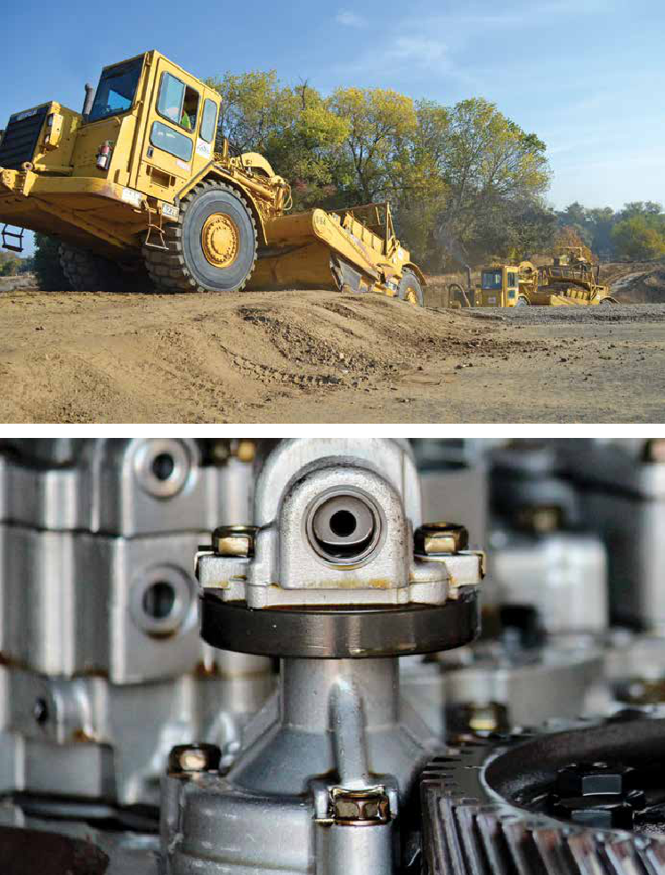

Solvents are a thing of the past. Parts washers are based on safe aqueous cleaning, so you eliminate the potential health hazards and disposal problems related to solvent use.

Nationwide Support

When you buy a parts washer from us, you’re assured of timely, professional service and support through our national network of distributors. They can provide you expert advice and support because they specialize exclusively in parts-washing equipment and supplies.

Specialized Detergents

Our detergents are designed specifically for use in our parts washers. We carefully design, blend and manufacture our own detergents to ensure they outperform all other parts cleaning detergents in the industry.

Global Cleaning Leader

Kärcher is recognized globally as a leader in cleaning solutions. In North America, Cuda Kärcher Group automatic parts washers deliver effective, time-saving solutions for professionals.

3

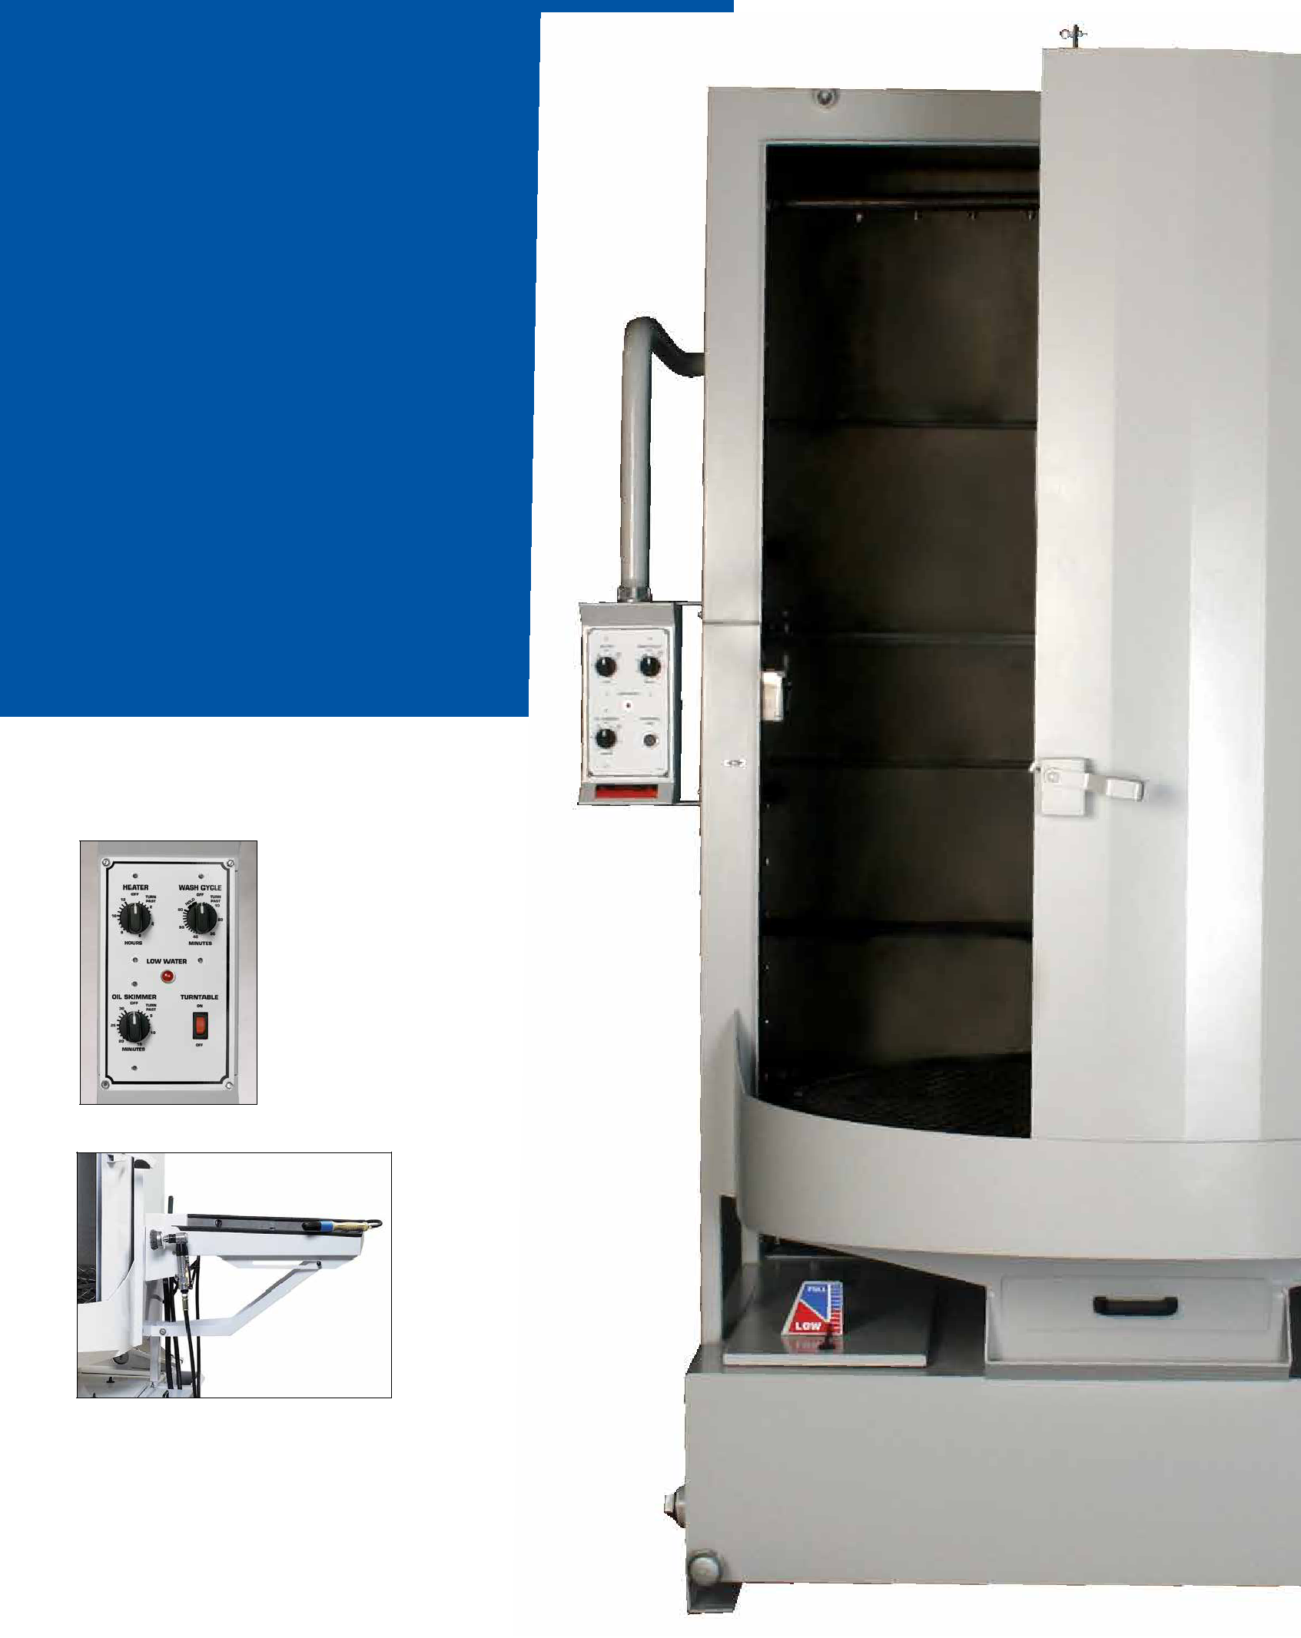
FRONT-LOAD AUTOMATIC AQUEOUS PARTS WASHERS | FEATURES & BENEFITS

SIMPLY EFFICIENT

Our line

of automatic aqueous parts

washers has provided a safe and

time-saving cleaning solution for

thousands of repair shops and

other businesses for over 25 years.

The many standard and optional

features available with your Cuda

are all designed to save you time

and money.

Control panel (all models) includes low-water indicator

light, oil skimmer, heater & wash-cycle timers and turntable ON/OFF switch.

Optional deluxe kit (all models) includes a fold-down detail tray, a detail brush that aids in cleaning those delicate or lightly soiled parts and a pneumatic power brush for those pieces that need cleaning attention. A dedicated sump (see below) also is part of the optional Deluxe Kit.

4

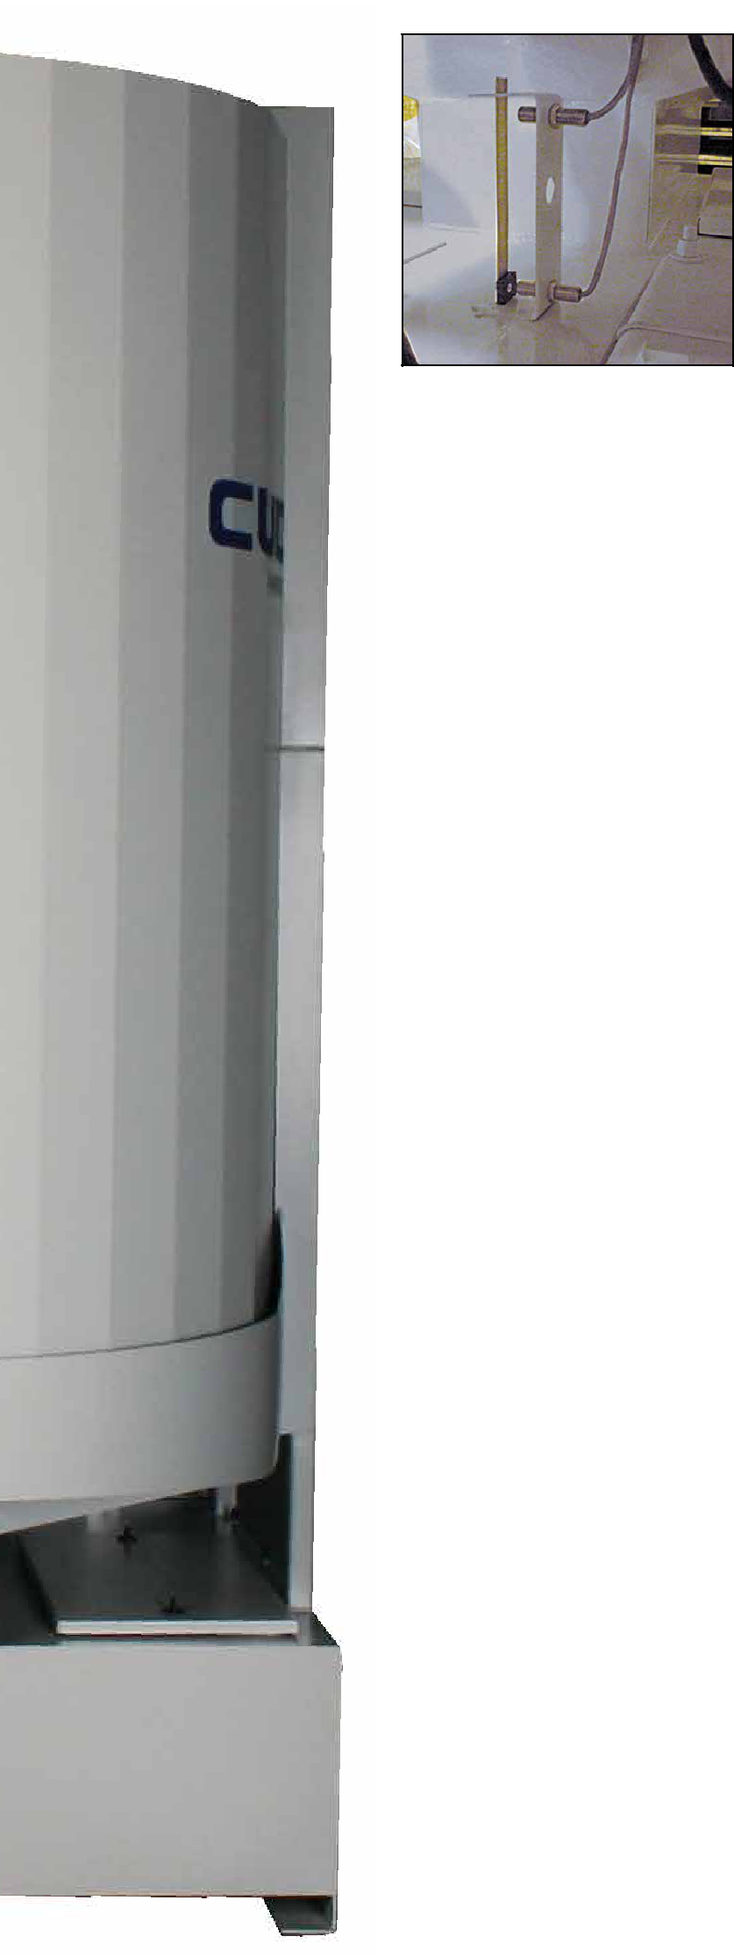

Automatic low-water shutoff (standard all models) enhances safety and protects heating element by automatically turning the unit off if the water level drops too low.
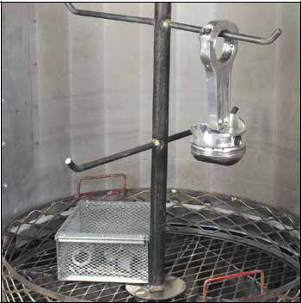

Optional drop-in parts tree slips into a recessed pocket of the turntable. Preferred package also includes small parts basket, containment ring and oil drain container.
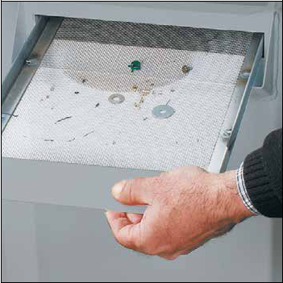

Removable debris screen (standard all models) prevents small particles and loose parts from entering the cleaning solution, ensuring blockage-free spray-nozzle operation.

Recessed entry allows easy-access to the entire wash area and minimizes stooping and lifting when loading heavy, awkward parts for cleaning.
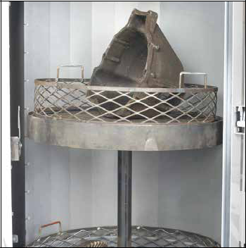
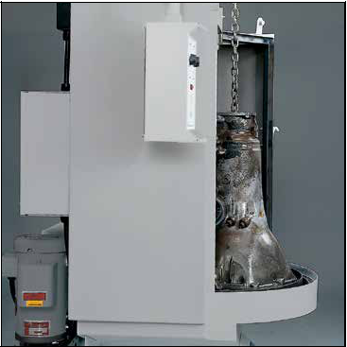

Optional two-tier turntable adds second level parts containment for greater parts washing capacity.
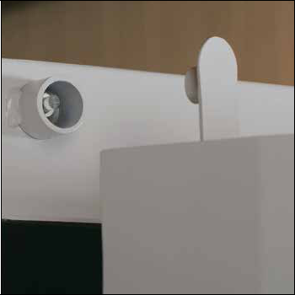

Door safety switch protects the operator from hot water spray if roll-in door is opened.

Optional dedicated sump is part of the deluxe kit and is completely independent of the main sump so it can be filled with any type of cleaning solution.
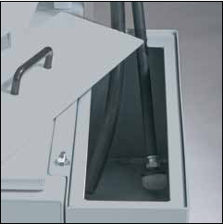
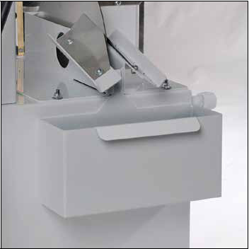

Built-in oil skimmer (standard all models) and optional oil drain container removes & collects oil from cleaning solution in sump.
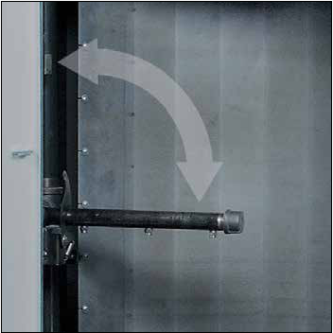

Retractable intermediate spray arm rotates down to clean small parts with or without the optional double-basket.

Designed for Safety, all models are ETL-Certified to the UL-73 standards. The ETL certification is proof that your Cuda has been independently tested and is in compliance to North American safety standards.

5

CUDA KÄRCHER GROUP | FRONT-LOAD AUTOMATIC AQUEOUS PARTS WASHERS
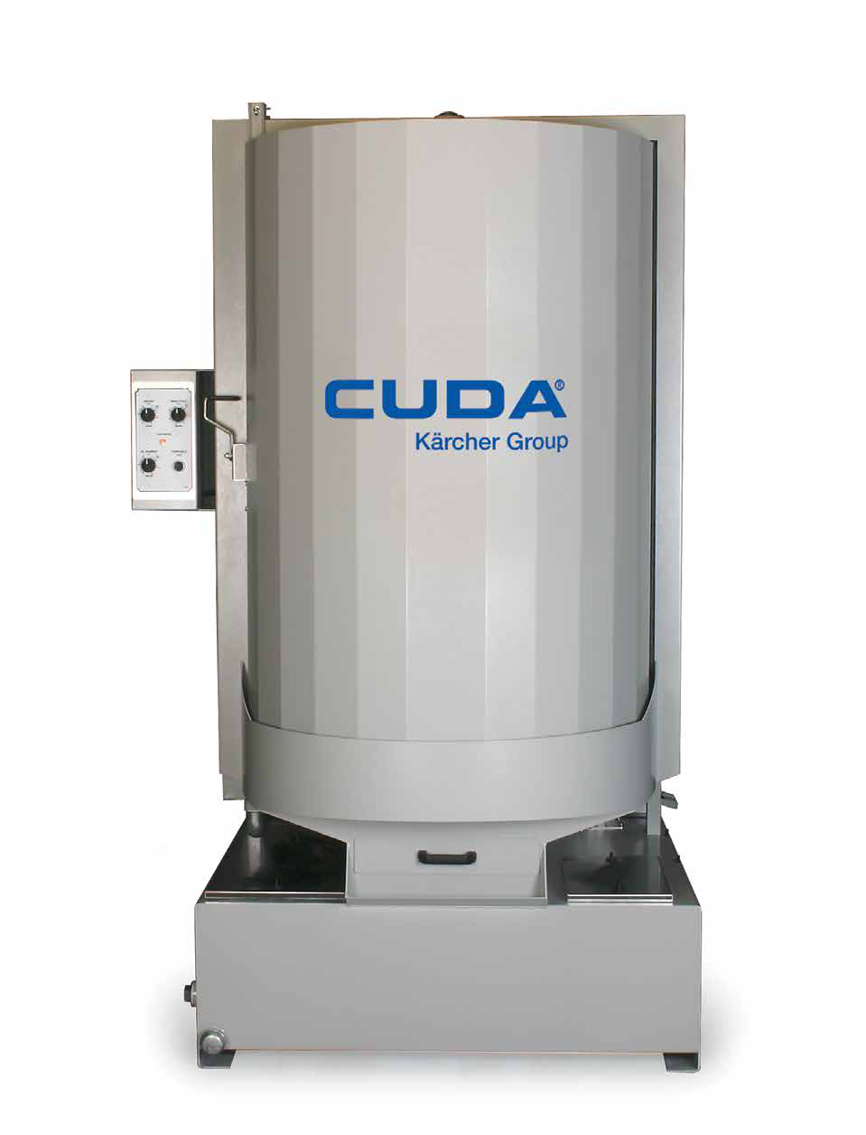

FRONT-LOAD AUTOMATIC PARTS WASHERS

Your go to choice when

bigger cleaning is required.

Capable of up to 5,000 pounds turntable load capacity,

front-load parts washers are easy to

use. Completely automatic and solvent-free, these rugged

“industrial-sized dishwashers” greatly simplify your parts

cleaning. Ergonomics and environmental-friendliness

blend nicely in our line of front-load parts washers with

turntables located knee-high, control panels chest-high, and

a curved, recessed entry that allows for easy loading and

un-loading. The unique space saving roll-in door design in

our front-load parts washers allow easy access to the wash

chamber and prevents the wash solution from dripping on

the floor. Seven series are available in a variety of electrical

configurations. Our front-load parts washers are ideal for

any industry cleaning all parts up through even the most

extra-large components.

• Choose from Seven Series Models

• Load Capacity 500 to 5,000 Lbs.

• 3 HP to 7.5 HP Vertical, Seal-less Pump

• 50 to 200 GPM @ 45 to 50 PSI

• Sump Capacity 40 to 200 Gallons

• 208V, 230V, 460V, and 575V Configurations
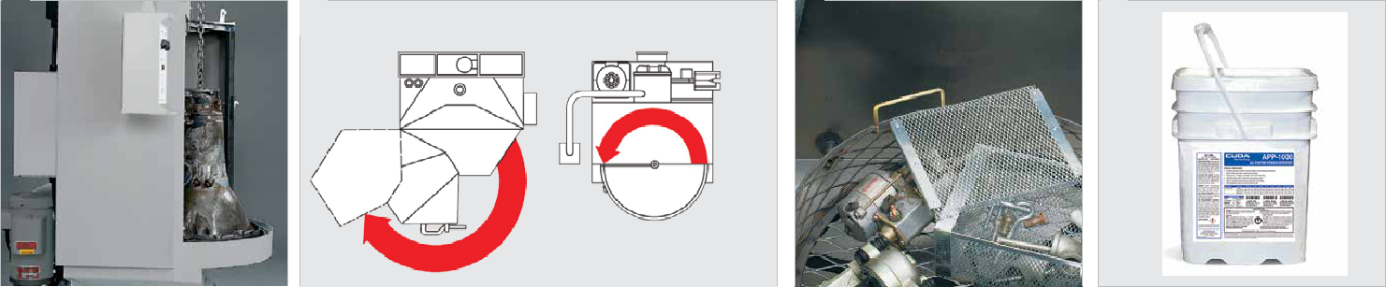

1 |  | 2 | TRADITIONAL | CUDA KÄRCHER GROUP | 3 |  | 4
 |  |  | PARTS WASHER | PARTS WASHER

 |  |  | TOP VIEW
1 | Recessed Entry |  |  | 3 | Customize and Accessorize

■■ Easy-access to the entire wash area.

■■ Reduces loading difficulty for unwieldy parts.

■■ Customize your parts washer to tailor to your specific needs and washing will become the easiest part of the work day.

2 | Compact Footprint

■■ Space saving roll-in door allows easy access to the wash chamber.

■■ Prevents wash solution from dripping on the shop floor.

TECHNICAL DATA AND EQUIPMENT
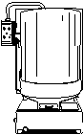
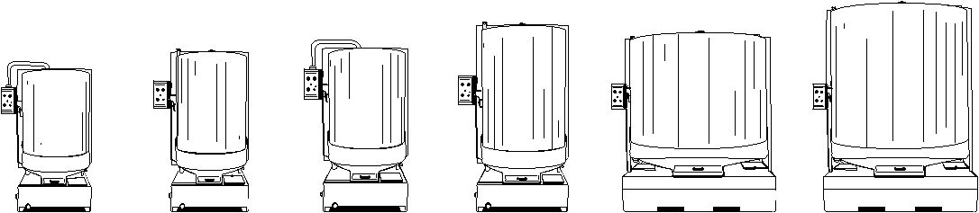

 | 2530 SERIES | 2840 SERIES | 2848 SERIES | 3648 SERIES | 4860 SERIES | 7248 SERIES | 7272 SERIES
Working Height | 30" | 40" | 48" | 48" | 60" | 48" | 72"
Turntable Diameter | 25" | 28" | 28" | 36" | 48" | 72" | 72"
Turntable Load Cap* | 500 lbs | 1000 lbs | 1000 lbs | 2500 lbs | 5000 lbs | 5000 lbs | 5000 lbs
Number of Nozzles | 12 | 12 | 18 | 21 | 26 | 26 | 32
Pump Motor | 3 HP | 3 HP | 5 HP | 7.5 HP | 7.5 HP | 7.5 HP | 7.5 HP
Pump Capacity | 50 GPM / 45 PSI | 50 GPM / 45 PSI | 110 GPM / 50 PSI | 150 GPM / 50 PSI | 200 GPM / 50 PSI | 160 GPM / 45 PSI | 180 GPM / 40 PSI
Sump Capacity | 40 gal | 50 gal | 50 gal | 113 gal | 156 gal | 200 gal | 160 gal
Electric Heater | 6 kW | 6 kW | 9 kW | (2) 9 kW | (2) 9 kW | (2) 9 kW | (2) 9 kW
Operating Temp | 150° — 170° | 150° — 170° | 150° — 170° | 150° — 170° | 150° — 170° | 150° — 170° | 150° — 170°
Electrical | 208 / 1 / 42 | 208 / 1 / 42 | 208 / 1 / 64 | — | — | — | —
(Volts / Phase / Amps)
 | 208 / 3 / 25 | 208 / 3 / 25 | 208 / 3 / 40 | — | — | — | —
 | 230 / 1 / 38 | 230 / 1 / 38 | 230 / 1 / 58 | — | — | — | —
 | 230 / 3 / 23 | 230 / 3 / 23 | 230 / 3 / 36 | 230 / 3 / 58 | 230 / 3 / 67 | 230 / 3 / 58 | 230 / 3 / 58
 | 460 / 3 / 11 | 460 / 3 / 11 | 460 / 3 / 17 | 460 / 3 / 32 | 460 / 3 / 32 | 460 / 3 / 32 | 460 / 3 / 32
 | 575 / 3 / 9 | 575 / 3 / 9 | 575 / 3 / 14 | 575 / 3 / 28 | 575 / 3 / 26 | 575 / 3 / 26 | 575 / 3 / 26
Dimensions (L x W x H) | 48" x 45" x 74" | 51" x 50" x 80" | 51" x 50" x 88" | 57" x 49" x 94" | 75" x 66" x 105" | 100" x 85" x 100" | 100" x 85" x 126"
Stainless Steel Models** | ■ | ■ | ■ | ■ | — | — | —

*Load capacity was determined with even weight distribution **Series also available in stainless steel with standard cast pump.

Standard Accessories

Preferred Options Package | Contains Parts Tree, Small Parts Basket, Containment Ring, Oil-Drain Container

NOTE: Preferred Options Package not available for 7248 series

Optional Accessories

Automatic Water Fill

Containment Ring

Filtration †

Filtration & Sump Sweep †

2 Stage Filtration

2 Stage Filtration & Sump Sweep

60 Mesh for Debris Screen Tray Insert

4 Hook Parts Tree

6 Hook Parts Tree (7272 Series only)

Heater Timer 24 hour 7 day

Heater Timer & Skimmer 24 hour 7 day

12" Height Extension (2848/4860 Series only)

12" Stainless Steel Height Extension (2848/4860 Series only) Deluxe Kit: Detail and Power Brush with Side Sink and Side Sump

Two-Tier Turntable  ‡
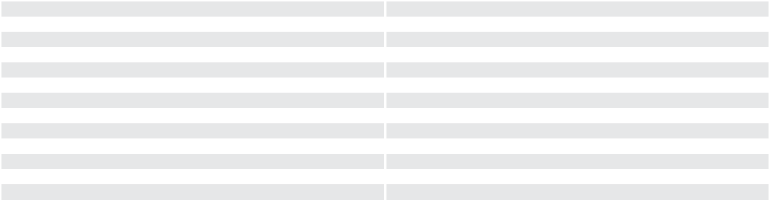

Stainless Steel Handle Kit, assembled ‡

Oil Drain Container

Hour Meter

PK-100D Sump Cleaner (Not available for 7248 Series)

PK-100D Filter Bag (Not available for 7248 Series)

Wastewater Drum Evaporator Belt (Not available for 7248 Series)

Light Duty Small Parts Basket (8" x 8" x 4") (Not available for 7248 Series)

Lid for Light Duty Small Parts Basket ‡

Light Duty Medium Parts Basket (16" x 12" x 6")

Lid for Light Duty Medium Parts Basket ‡

Gray Spray Paint

Vertical Center Wash Bar (7272 Series only)

 Requires Light Duty Small Parts Basket and Containment Ring sold separately, not for height extended machines † 2848 Series & Smaller Only Only 3648 Series & Larger Only ‡ Not available for 7248/7272 Series

